Group 36 | DormToDorm


Project Phase 1 & 2
(CMPG321)

Group Members:
48241172 – A.S. Aswat – (Group Leader)
37683926 – E. van Loggerenberg
42262186 – R. Wehmeyer

Submission date: 13/10/2026
Table of Contents
Group Information 4
Phase 1 – Focus Area and Requirements Analysis 6
1. Area of Focus 6
1.1 Chosen Focus Area 6
1.2 Why This Focus Area 6
1.3 Business Value and Intended Decisions 6
1.4 Scope Boundaries 7
1.5 Supplementary Data 7
2. Research Questions 8
2.1 Theme A — Payment Channel Adoption and Substitution 8
2.2 Theme B — Rider Spend, Basket Composition and Trip Economics 8
2.3 Theme C — Tipping Behaviour 9
2.4 Theme D — Payment Failure and Revenue Leakage 9
2.5 Theme E — Promotions and Rider Retention 9
3. Dataset Description 10
3.1 Overview 10
3.2 Entity Relationships 10
3.3 File-Level Descriptions 11
3.4 Payment Method Domain - the Analytical Centre of the Project 14
3.5 Geographic Distribution 15
3.6 Data Quality Observations 15
3.7 Fitness for the Chosen Focus Area 16
3.8 Assumptions, Limitations and Phase 2 Readiness 17
Phase 2 – DB Implementation and Analysis 18
Executive Summary 18
4. DB Design and Setup 19
4.1 Platform and environment 19
4.2 Design approach 19
4.3 Profiling results that shaped the design 19
4.4 Normalisation decisions 20
4.5 Implemented tables 21
4.6 Data types, domains and constraints 21
4.7 Indexing strategy 22
4.8 Loading the data 23
4.9 Delivered scripts 24
5. Schema / ERD 25
5.1 Relationships 26
6. SQL Query Development 27
6.1 Conventions 27
6.2 Technique coverage 27
6.3 Query listings 28
6.4 Transactions and programmability 43
6.5 Optimisation 46
7. Analysis and Reporting 47
7.1 Theme A - Payment channel adoption and substitution 47
7.2 Theme B - Rider spend, basket composition and trip economics 51
7.3 Theme C - Tipping behaviour 55
7.4 Theme D - Payment failure and revenue leakage 57
7.5 Theme E - Promotions and rider retention 59
8. Recommendations 61
9. Limitations and Conclusion 62
9.1 Limitations 62
9.2 Conclusion 62
10. Video Demonstration Plan 63
Appendix A - Data Dictionary 64

Group Information
Group name: DormToDorm Group number: 36 Module: CMPG321 (2026)
# | Full name & surname | Student number | Role | Contact (email) | Photo
1 | Abu-Bakr Siddik Aswat | 48241172 | Group Leader | abubakraswat@gmail.com  48241172@mynwu.ac.za | [insert photo]
2 | Eckardt van Loggerenberg | 37683926 | Member | eckardt.vanloggerenberg@gmail.com | 
3 | Rieghardt Wehmeyer | 42262186 | Member | 42262186@mynwu.ac.za | [insert photo]

Declaration of Work Allocation - Phase 1
Deliverable | Responsible Member(s) | Status
Area of focus definition and justification | Abu | Complete
Research question formulation | Eckardt | Complete
Dataset profiling and description | Rieghardt | Complete
Report compilation and quality review | Abu / Eckardt / Rieghardt | Complete
Phase 2 schema design (preparatory) | Abu / Eckardt / Rieghardt | In progress

Declaration of Work Allocation - Phase 2
Deliverable | Responsible member(s) | Status
Database design, DDL and constraints (scripts 01-02) |  | Complete
Data cleansing, transactional load and reconciliation (script 03) |  | Complete
ERD and data dictionary |  | Complete
Analytical SQL query set RQ1-RQ19 (script 04) |  | Complete
Transactions, trigger, stored procedure and view (script 05) |  | Complete
Performance testing and optimisation (script 06) |  | Complete
Analysis, visualisations and recommendations |  | Complete
Report compilation and quality review |  | Complete
Video demonstration (5-8 minutes) |  | In progress

Phase 1 - Focus Area and Requirements Analysis

Area of Focus

Chosen Focus Area
Rider Purchasing Patterns and Payment Channel Preferences - a consumer- and revenue-side analysis of how South African e-hailing riders spend, how much they spend, which payment instruments they choose, and how that choice affects trip completion, tipping and revenue leakage.
The group analyses the dataset from the perspective of a platform revenue and payments team responsible for growing gross bookings per rider while reducing failed and abandoned payments.

Why This Focus Area
South Africa is one of the few large e-hailing markets where cash remains a first-class payment method rather than a legacy fallback. In the dataset supplied, cash accounts for the single largest share of trip requests, ahead of credit card. That single fact creates a commercially meaningful tension that the other candidate focus areas do not surface:
- Cash trips almost never fail at the point of payment, but they carry settlement risk, driver safety exposure and no digital trail for loyalty or credit products.
- Card trips digitise the transaction, but they fail. Debit card - the instrument most accessible to lower-income and younger riders - shows the highest payment failure rate in the dataset.
- Tipping behaviour is not uniform across instruments, so the payment mix directly changes driver take-home pay even when the fare is identical.
A platform therefore cannot simply push every rider to cards. It needs evidence on which rider segments, in which cities, on which trip types, can be migrated to a digital instrument without losing the trip. That is the question this project answers.

Business Value and Intended Decisions
The analysis is scoped so that every research question maps to a decision a real payments or growth team would have to make:
Decision to be supported | Evidence the analysis will produce
Where to target a cash-to-digital migration campaign | Cash dependency ranked by city, province, zone type, age band and loyalty tier, cross-referenced with digital failure rates in the same segment
Whether to subsidise or discourage a payment instrument | Revenue per settled trip, tip attachment rate and failure rate by instrument, net of promotional discount
How to price and position promotions | Promotional discount penetration and its effect on basket size, repeat frequency and instrument switching
Which riders to prioritise for retention | Recency, frequency and monetary value segmentation of the rider base, and spend concentration across the top decile
How to reduce revenue leakage | Value of trips lost to payment failure and to surge-driven rider cancellation, by instrument and by zone

Scope Boundaries
In scope | Out of scope (deliberately excluded)
Rider-side monetary behaviour: fare paid, tips, promotions, basket composition | Driver earnings optimisation and shift profitability (a separate focus area)
Payment instrument choice, substitution and failure | Route-level geospatial optimisation and ETA modelling
Spend segmentation by demographic, geography and loyalty tier | Vehicle maintenance, roadworthiness and fleet quality control
The monetary consequence of cancellations and failed payments | Predictive machine-learning models - the analysis is descriptive and diagnostic, delivered in SQL
Excluded areas are still referenced where they are causally relevant. Surge multiplier, for example, is a pricing variable and is used as an explanatory factor for rider cancellation, but surge itself is not the object of study.

Supplementary Data
The brief permits additional resources. The group intends to enrich the analysis with:
- Statistics South Africa provincial household income and metro population figures, to normalise spend per capita rather than comparing raw provincial totals.
- South African Reserve Bank and PayInc published card-versus-cash payment adoption statistics, to benchmark the dataset's payment mix against the national picture.
- A public South African school-holiday and public-holiday calendar, loaded as a small date-dimension table, so that seasonal spend spikes can be attributed correctly.
Each supplementary source will be loaded as a separate reference table in Phase 2 and joined on province, city or date. No supplementary source will be used to alter the transactional records themselves.

Research Questions
Nineteen research questions are grouped into five themes. Every question is answerable from the supplied dataset alone, is expressed at a stated grain, and names the SQL technique that will produce it in Phase 2. Questions are numbered RQ1-RQ19 and are referenced by number in the Phase 2 query set.

Theme A - Payment Channel Adoption and Substitution
ID | Research question | Why it matters / how it will be answered
RQ1 | What is the share of trip requests and of settled revenue attributable to each payment method, and how does that split differ between the two platforms? | Establishes the baseline payment mix. GROUP BY on payment_method with a conditional aggregate over trip_status; revenue share computed as a window function over the grand total.
RQ2 | Which cities and zone types are most cash-dependent, and does cash dependency track the affluence and zone profile of the pickup area? | Targets the migration campaign geographically. Three-table join from trip_headers to pricing_surge_zones and trip_fare_breakdown, aggregated by city and zone_type.
RQ3 | How does preferred payment method vary by rider age band, gender, loyalty tier and rider segment? | Identifies the demographic profile of the addressable cash population. Multi-dimension GROUP BY with ROLLUP over the rider dimension.
RQ4 | How often do riders transact on an instrument other than their stated preferred method, and which substitutions are most common? | Measures the gap between stated and revealed preference - a substitution matrix built by joining trip_headers.payment_method against sa_riders.preferred_payment_method and pivoting with conditional aggregation.
RQ5 | Among riders who used more than one instrument, is there evidence of durable migration from cash to a digital method over the twelve-month window? | Cohort question. First and last instrument per rider derived with FIRST_VALUE / LAST_VALUE window functions partitioned by rider_id and ordered by request_timestamp.

Theme B - Rider Spend, Basket Composition and Trip Economics
ID | Research question | Why it matters / how it will be answered
RQ6 | What is the distribution of gross fare per settled trip, and how do the median and upper quartile differ by province and ride category? | Describes the spend distribution rather than the mean alone, which is skewed by long airport trips. PERCENTILE_CONT / NTILE analytical functions grouped by province.
RQ7 | How is the total fare composed - base fare, distance charge, time charge, surge premium, booking fee, tolls, waiting charges - and how does that composition change across ride categories? | Shows which fare component drives spend. Aggregation across trip_fare_breakdown with each component expressed as a percentage of gross_fare_zar.
RQ8 | Is there a relationship between trip distance and spend efficiency measured in rand per kilometre, and at what distance does rand per kilometre stop falling? | Tests whether long trips are good value for the rider. Distance bucketed with CASE or WIDTH_BUCKET, then aggregated.
RQ9 | How does average spend per trip vary by hour of day, day of week and weekend flag, and where do the highest-value windows sit? | Feeds promotional timing. Time bucketing on hour_of_day and day_of_week with a HAVING filter on minimum trip volume.
RQ10 | What proportion of settled revenue is contributed by the top decile of riders by lifetime spend, and what characterises that decile? | Tests revenue concentration. NTILE(10) over cumulative spend per rider, then a profile join back to sa_riders.
RQ11 | How do airport trips differ from non-airport trips in fare value, instrument mix and tipping? | Airport trips are a distinct high-value basket. Filter on is_airport_trip with a comparative aggregate.

Theme C — Tipping Behaviour
ID | Research question | Why it matters / how it will be answered
RQ12 | What is the tip attachment rate and the average tip value for each payment method, and is the difference material to driver take-home pay? | Directly links payment strategy to driver earnings. Conditional aggregate on tip_amount_zar > 0 grouped by payment_method.
RQ13 | Does a higher rating given by the rider translate into a higher tip, and does the relationship hold once payment method is controlled for? | Tests whether service quality or payment friction drives tipping. Join trip_reviews to trip_fare_breakdown, aggregate by rating_given within payment_method.
RQ14 | Do surge-priced trips suppress tipping, and does the suppression grow with the surge multiplier? | Isolates a pricing side effect. Surge multiplier bucketed, tip rate compared across buckets with a subquery baseline.

Theme D — Payment Failure and Revenue Leakage
ID | Research question | Why it matters / how it will be answered
RQ15 | What is the payment failure rate for each instrument, and what is the total rand value of trips lost to failed payment over the period? | Quantifies the cost of digitisation. Conditional aggregate on trip_status = 'Payment Failed' joined to the fare record that was never settled.
RQ16 | Are riders who experience a payment failure more likely to switch instrument, or to stop transacting altogether, in the following thirty days? | Measures the downstream churn cost of a failure. Self-join or LAG/LEAD window over each rider's ordered trip history.
RQ17 | Which pickup zones combine a high surge multiplier with a high rider-cancellation rate attributed to surge price friction, and what revenue does that represent? | Separates price-driven abandonment from supply-driven abandonment. Join to pricing_surge_zones, filter on cancellation_reason, rank zones with RANK().

Theme E — Promotions and Rider Retention
ID | Research question | Why it matters / how it will be answered
RQ18 | What share of settled trips carries a promotional discount, what does that cost in rand, and do discounted riders return sooner than undiscounted riders? | Tests promotional return on investment. Days-to-next-trip computed with LEAD over rider trip history, compared across discounted and undiscounted cohorts.
RQ19 | Using recency, frequency and monetary value, how does the rider base segment, and how does payment instrument mix differ across those segments? | Delivers the final actionable segmentation. A common table expression computing R, F and M per rider, scored with NTILE, then profiled against payment behaviour.

Dataset Description

Overview
The dataset comprises seven delimited flat files in comma-separated value format, UTF-8 encoded, with a single header row per file. It covers e-hailing activity on the Uber and Bolt platforms across seven South African urban areas in five provinces, for the twelve-month period 1 July 2025 to 30 June 2026 inclusive.
File | Grain (one row = ) | Rows | Cols | Role
sa_riders.csv | one registered rider | 3 200 | 14 | Dimension
sa_drivers.csv | one registered driver | 900 | 15 | Dimension
vehicles.csv | one licensed vehicle | 900 | 12 | Dimension
pricing_surge_zones.csv | one tariff / surge zone | 37 | 15 | Dimension
trip_headers.csv | one trip request | 60 000 | 24 | Fact
trip_fare_breakdown.csv | one billable fare record | 50 431 | 18 | Fact
trip_reviews.csv | one post-trip review | 20 481 | 10 | Fact
Total volume is approximately 19 MB across 135 949 records. The three fact files are transactional; the four dimension files are reference data with no repeating rows.

Entity Relationships
The files form a star-like structure around trip_headers, which is the central fact table:
- sa_riders (1) → trip_headers (many) on rider_id - 3 148 of the 3 200 riders transacted at least once.
- sa_drivers (1) → trip_headers (many) on driver_id - every driver appears in the trip log.
- vehicles (1) → sa_drivers (1) on vehicle_id - a strict one-to-one; each driver operates exactly one vehicle.
- pricing_surge_zones (1) → trip_headers (many), twice, on pickup_zone_id and dropoff_zone_id - a role-playing dimension that will require two aliased joins in Phase 2.
- trip_headers (1) → trip_fare_breakdown (0..1) on trip_id - a fare record exists only where money was due. Completed and payment-failed trips have one; cancelled and unfulfilled trips have none.
- trip_headers (1) → trip_reviews (0..1) on trip_id - reviews are voluntary and cover 41.8% of completed trips.
The optional cardinality on the two fact-to-fact relationships is the most important structural feature for this focus area: any analysis of spend must inner-join to trip_fare_breakdown, while any analysis of demand or abandonment must left-join, or the cancelled trips disappear.

File-Level Descriptions

sa_riders.csv - rider dimension
Column | Type | Domain / range | Notes
rider_id | CHAR(7) | R000001 - R003200, 3 200 distinct | Primary key. Fixed-width, zero-padded.
first_name / last_name | VARCHAR(40) | 52 / 48 distinct values | Personally identifying; excluded from all published output.
age_band | VARCHAR(6) | 18-24, 25-34, 35-44, 45-54, 55-64, 65+ | Ordinal. Banded at source, so no exact age is available.
gender | VARCHAR(20) | Female, Male, Other/Undisclosed | Nominal.
home_city | VARCHAR(20) | 7 values (Johannesburg … Potchefstroom) | Functionally determines province - a transitive dependency to normalise in Phase 2.
province | VARCHAR(20) | Gauteng, Western Cape, KwaZulu-Natal, Eastern Cape, North West | Nominal.
signup_date | DATE | 2024-01-01 - 2025-12-01 | ISO 8601. Used for tenure calculations.
preferred_payment_method | VARCHAR(15) | 8 values (see §3.4) | Stated preference. Compared against revealed behaviour in RQ4.
loyalty_tier | VARCHAR(10) | Bronze, Silver, Gold, Platinum | Ordinal. Bronze is the modal tier at 52%.
rider_segment | VARCHAR(12) | Standard, Frequent, Corporate, Occasional | Platform-assigned behavioural label.
corporate_account_flag | CHAR(1) | Y / N | Boolean surrogate. Stored as a character, so a CHECK constraint is required.
avg_rider_rating | DECIMAL(3,2) | 3.83 - 5.00, mean 4.71 | Rating the rider receives from drivers.
account_status | VARCHAR(10) | Active (90%), Dormant (8.5%), Suspended (1.5%) | Suspended riders generate no trips.

trip_headers.csv - trip fact
The central operational log. Every trip request appears here whether or not it was fulfilled.
Column | Type | Domain / range | Notes
trip_id | CHAR(8) | T0000001 - T0060000 | Primary key.
rider_id | CHAR(7) | FK → sa_riders | 3 148 distinct riders.
driver_id / vehicle_id | CHAR(6) | FK → sa_drivers / vehicles | Vehicle is redundant given driver; retained for query convenience.
platform | VARCHAR(5) | Uber, Bolt | Determined by ride_category.
ride_category | VARCHAR(15) | UberGo, UberX, Uber Comfort, UberXL, Bolt Go, Bolt Economy, Bolt Comfort, Bolt XL | Eight tiers across two platforms.
request_timestamp | TIMESTAMP | 2025-07-01 00:47 - 2026-06-30 23:29 | Always populated. The analysis clock.
pickup_timestamp | TIMESTAMP | NULL on all unfulfilled trips | Populated for 49 049 completed trips only.
dropoff_timestamp | TIMESTAMP | NULL on all unfulfilled trips | As above.
pickup_zone_id / dropoff_zone_id | CHAR(5) | FK → pricing_surge_zones, 37 values | Role-playing dimension; both always within the same city.
city / province | VARCHAR(20) | 7 / 5 values | Denormalised copies of the zone attributes.
trip_distance_km | DECIMAL(6,2) | 0.80 - 111.67, mean 7.78 | NULL where the trip did not complete. Right-skewed; airport trips form the long tail.
trip_duration_min | DECIMAL(6,1) | 2.7 - 225.4, mean 18.97 | NULL where the trip did not complete.
wait_time_min | DECIMAL(4,1) | 0.5 - 17.2, mean 6.01 | Populated on every request, including cancellations.
surge_multiplier | DECIMAL(4,2) | 1.00 - 2.86, mean 1.29 | 1.00 means no surge. Bounded above by the zone's max_surge_multiplier.
trip_status | VARCHAR(20) | Completed 81.75%, Cancelled by Rider 8.35%, Cancelled by Driver 5.67%, Payment Failed 2.30%, No Driver Found 1.93% | The controlling status field for every filter in this project.
cancellation_reason | VARCHAR(25) | 10 values incl. Driver Too Far, Rider No-Show, Surge Price Friction, Card Declined, No Supply In Zone | Empty string on completed trips - must be normalised to NULL on load.
payment_method | VARCHAR(15) | 8 values | The instrument attempted, not necessarily the rider's stated preference.
day_of_week / hour_of_day | VARCHAR(9) / SMALLINT | Monday–Sunday / 0-23 | Derived from request_timestamp; retained as pre-computed columns for query performance.
is_weekend / is_airport_trip | CHAR(1) | Y / N | Boolean surrogates.

trip_fare_breakdown.csv - fare fact
The monetary spine of this focus area. All amounts are in South African rand, two decimal places.
Column | Type | Domain / range | Notes
fare_id | CHAR(8) | F0000001 - F0050431 | Primary key.
trip_id | CHAR(8) | FK → trip_headers, unique | One-to-one where present; a UNIQUE constraint is required.
base_fare_zar | DECIMAL(8,2) | 16.00 - 38.00 | Only 8 distinct values - determined by ride_category.
distance_charge_zar | DECIMAL(8,2) | 4.72 - 1 030.80, mean 61.30 | Largest single fare component.
time_charge_zar | DECIMAL(8,2) | 2.15 - 212.84, mean 16.02
surge_premium_zar | DECIMAL(8,2) | 0.00 - 1 113.77, mean 30.23 | Zero on 47.9% of records. Zero-inflated - the mean is misleading without a non-zero filter.
booking_fee_zar | DECIMAL(6,2) | 4.56 - 9.17 | Set per zone, not per trip.
toll_fee_zar | DECIMAL(6,2) | 0.00 - 27.99, mean 0.46 | Non-zero on Gauteng toll routes only. Not commissionable.
waiting_charge_zar | DECIMAL(6,2) | 0.00 - 19.52 | Levied only above a five-minute wait.
promo_discount_zar | DECIMAL(6,2) | 0.00 - 59.95 | Non-zero on 10.7% of trips. Reduces gross fare.
tip_amount_zar | DECIMAL(6,2) | 0.00 - 180.00, mean 5.02 | Zero-inflated. Attachment rate varies from 16% to 44% by instrument.
gross_fare_zar | DECIMAL(9,2) | 24.25 - 2 061.89, mean 143.03 | Total charged to the rider. Total settled value over the period is R7 024 628.
platform_commission_zar | DECIMAL(8,2) | 0.00 - 492.56 | 25% on Uber, 20% on Bolt, applied net of tip and toll.
driver_net_payout_zar | DECIMAL(9,2) | 0.00 - 1 642.21 | gross_fare_zar less commission. Zero on failed payments.
payment_method | VARCHAR(15) | 8 values | Duplicated from trip_headers - a redundancy to resolve in Phase 2 normalisation.
payment_status | VARCHAR(10) | Settled, Failed | Failed records carry a fare but no payout.
currency | CHAR(3) | ZAR only | Single-valued; a candidate for removal.
settlement_date | DATE | 1-4 days after the trip | Empty on failed payments.

pricing_surge_zones.csv - tariff and zone dimension
Column | Type | Domain / range | Notes
zone_id | CHAR(5) | Z0001 - Z0037 | Primary key.
zone_name / city / province | VARCHAR(30) | 37 / 7 / 5 values | e.g. Sandton CBD, Khayelitsha, OR Tambo Precinct.
zone_type | VARCHAR(20) | Business District, Residential, Airport, Nightlife, Campus, Township, Retail Hub | The key explanatory attribute for cash dependency in RQ2.
base_fare_zar / per_km_rate_zar / per_minute_rate_zar / minimum_fare_zar / booking_fee_zar | DECIMAL(6,2) | 16.26-31.57 / 6.18-12.34 / 0.62-1.30 / 24.04-57.62 / 4.56-9.17 | The published tariff card per zone.
avg_surge_multiplier / max_surge_multiplier | DECIMAL(4,2) | 1.00-1.92 / 1.54-3.23 | Zone-level surge envelope. Constrains the per-trip multiplier.
peak_window | VARCHAR(11) | 06:00-09:00, 16:00-19:00, 21:00-02:00, All Day | Stored as text; requires parsing or a lookup table in Phase 2.
avg_driver_supply_index | DECIMAL(4,2) | 0.43 - 1.27 | Below 1.00 indicates chronic under-supply. Separates price-driven from supply-driven abandonment.
toll_route_flag | CHAR(1) | Y / N | Explains non-zero toll_fee_zar.

sa_drivers.csv, vehicles.csv and trip_reviews.csv - supporting files
These three files sit outside the primary focus area but are used as controls and explanatory joins.
File / key columns | Domain highlights | Use in this focus area
sa_drivers - driver_id (PK), vehicle_id (FK), platform, commission_rate_pct, driver_rating, cancellation_rate_pct | 900 drivers; rating 4.18-5.00; commission 20% (Bolt) or 25% (Uber); cancellation rate 0.5%-20.8% | Supplies commission_rate_pct for revenue-split analysis and driver cancellation propensity as a control in RQ17.
vehicles - vehicle_id (PK), make, model, model_year, vehicle_age_years, vehicle_category, fuel_type | 900 vehicles; 10 makes, 32 models; model year 2013-2025; age 1-13 years | Used only to confirm that spend differences across ride categories are not confounded by vehicle tier.
trip_reviews - review_id (PK), trip_id (FK), rider_id, driver_id, rating_given, review_category, sentiment_label, escalated_flag | 20 481 reviews; rating 1-5, mean 4.34; six review categories; sentiment Positive / Neutral / Negative | Central to RQ13. The Pricing & Payment review category isolates payment friction expressed in rider feedback.

Payment Method Domain - the Analytical Centre of the Project
The payment_method domain has eight members. The profile below is drawn from the supplied data and is the empirical starting point for Theme A and Theme D.
Payment method | Share of requests | Settled trips | Avg gross fare | Tip attach. | Failure rate | Digital
Cash | 27.05% | 13 433 | R143.33 | 43.99% | 0.38% | No
Credit Card | 23.89% | 11 616 | R143.87 | 36.82% | 3.17% | Yes
Debit Card | 20.56% | 9 872 | R142.33 | 23.93% | 4.55% | Yes
In-App Wallet | 13.96% | 6 926 | R144.34 | 31.23% | 1.64% | Yes
SnapScan | 4.92% | 2 428 | R140.15 | 19.81% | 2.51% | Yes
Apple Pay | 3.90% | 1 947 | R145.60 | 34.51% | 1.03% | Yes
Zapper | 3.17% | 1 568 | R139.23 | 16.07% | 2.73% | Yes
Google Pay | 2.54% | 1 259 | R143.93 | 32.57% | 1.12% | Yes
Three observations already justify the focus area. Average fare is essentially flat across instruments - between R139 and R146 - so instrument choice is not a proxy for basket size. Tip attachment, by contrast, ranges from 16.07% to 43.99%, a spread of nearly three times. And failure rate ranges from 0.38% to 4.55%, concentrated in exactly the card products a migration campaign would push riders toward. The commercial question is therefore not whether digital payment is better in the abstract, but which segments can absorb a failure rate an order of magnitude above cash without abandoning the platform.

Geographic Distribution
Province | Settled trips | Avg gross fare | Metros represented
Gauteng | 25 061 | R149.58 | Johannesburg, Pretoria, Vanderbijlpark
Western Cape | 9 781 | R145.29 | Cape Town
KwaZulu-Natal | 8 412 | R144.96 | Durban
Eastern Cape | 3 931 | R113.25 | Gqeberha
North West | 1 864 | R102.09 | Potchefstroom
Gauteng dominates by volume and carries the highest average fare, partly because it is the only province with toll routes in the dataset. The R47 gap between Gauteng and North West average fares is large enough that all cross-provincial comparisons in Phase 2 will be normalised per kilometre rather than compared on absolute fare.

Data Quality Observations
Profiling surfaced seven issues that shape the Phase 2 load and schema design:
# | Observation | Treatment in Phase 2
1 | Empty strings rather than NULL in cancellation_reason, pickup_timestamp, dropoff_timestamp, trip_distance_km, trip_duration_min and settlement_date | Convert empty strings to NULL on load via a staging table, then apply NOT NULL constraints only where genuinely mandatory.
2 | payment_method is stored in both trip_headers and trip_fare_breakdown | Retain on trip_headers (the attempt) and drop from the fare table, or enforce equality with a CHECK; the redundancy will be documented in the ERD.
3 | city and province are denormalised onto trip_headers although both are determined by zone_id | Normalise into a location dimension; keep the denormalised columns only if query performance requires it, and justify the decision.
4 | currency is single-valued (ZAR on every row) | Retain the column but constrain it, so the schema tolerates future multi-currency data without a structural change.
5 | Booleans are stored as 'Y' / 'N' characters | Load as CHAR(1) with a CHECK constraint, or cast to a native boolean type where the chosen DBMS supports one.
6 | surge_premium_zar, tip_amount_zar and promo_discount_zar are zero-inflated | Analytical rather than structural. Every aggregate over these columns will be reported both including and excluding zero rows.
7 | 52 riders in sa_riders have no trips, and roughly 58% of completed trips have no review | Expected and correct. Requires deliberate use of outer joins so that non-transacting riders and unreviewed trips are not silently dropped.

Fitness for the Chosen Focus Area
Requirement of the focus area | Supported by
Rider spending habits | trip_fare_breakdown (11 monetary columns) joined to sa_riders across 50 431 fare records
Trip distance distributions | trip_distance_km on 49 049 completed trips, range 0.80-111.67 km
Tip frequency | tip_amount_zar, zero-inflated, analysable by instrument, rating, surge band and geography
Payment method adoption | Eight-member payment_method domain present on both the header and the fare record, plus a stated preference on the rider record
Payment failure correlation | trip_status = 'Payment Failed' on 1 382 requests with a matching unsettled fare record, and payment_status on the fare table
Cancellation correlation | cancellation_reason across 10 values on 9 569 abandoned requests, joinable to zone surge and supply attributes
Provincial comparison | Five provinces, seven metros, 37 zones with a zone_type classification
Every element the brief names for this focus area is present in the supplied data at sufficient volume for statistically meaningful aggregation. No element of the focus area depends on data the group does not have.

Assumptions, Limitations and Phase 2 Readiness

Assumptions
- The twelve-month window is treated as a complete and representative period; no adjustment is made for seasonality beyond the holiday calendar noted in §1.5.
- All monetary values are nominal rand and are not inflation-adjusted across the period.
- preferred_payment_method on the rider record reflects the rider's setting at extract time, not at the time of each historical trip. RQ4 is interpreted accordingly.
- A driver operates exactly one vehicle for the whole period; the data contains no vehicle-change history.

Limitations
- The dataset contains no rider income or household data, so affluence can only be inferred from geography and loyalty tier.
- Reviews are voluntary and cover 41.8% of completed trips, so sentiment findings carry self-selection bias. This will be stated wherever review data is used.
- Failure reasons are coarse - 'Card Declined' does not distinguish insufficient funds from an expired card or a network timeout, which limits how prescriptive the recommendations in RQ15 can be.
- The analysis is observational. Correlations between payment instrument and outcome cannot establish causation, and the report will not claim otherwise.

Phase 2 Readiness
The group has confirmed the following before proceeding:
- A primary key candidate exists for every file, and every foreign key resolves with no orphan records.
- Data types and domains have been established for all 108 columns across the seven files.
- Each of the nineteen research questions has been traced to the specific tables and columns that answer it, and to the SQL technique required.

Phase 2 – DB Implementation and Analysis

Executive Summary
Phase 2 implements the Phase 1 design in Microsoft SQL Server 2022 and answers all nineteen research questions with SQL. All 135 949 records from the seven CSV files load into a 13-table, third-normal-form schema guarded by 62 CHECK constraints, 15 foreign keys and 10 unique constraints. The load runs as one transaction and reconciles to the cent: settled revenue of R7 024 627.53 in the database matches the source files exactly.
The analysis supports one central conclusion: South African riders do not need convincing to pay digitally - they need a digital instrument that does not fail. Seven findings carry the recommendations:
- Cash is stable at about 27% of requests (monthly range 25.8%-27.9%). As many riders drift from digital to cash as from cash to digital (284 vs 282), so there is no organic migration to ride on.
- Cash dependency is highest in the smaller metros and among young riders. Potchefstroom (38.8%) and Vanderbijlpark (33.1%) lead every city; riders aged 18-24 state a cash preference of 37.4% against 22.1% for 45-54.
- Debit card is the weakest instrument. It fails on 4.55% of requests, against 1.64% for the in-app wallet and about 1% for Apple Pay and Google Pay. Cards account for 73.5% of the R188 482 in fares lost to failed payments.
- A failed payment pushes riders back to cash, but does not drive them away. After a failure, 9.4% of riders return on cash (vs 7.3% after a normal trip), while the 30-day drop-off rate is unchanged.
- Payment channel, not service quality, drives tipping. Cash trips are tipped 44.0% of the time against 23.9% for debit card; rating given and surge level make no material difference.
- Surge above 1.5x is a cliff. Rider cancellations for surge friction jump from under 1% to 5.3% (1.51-2.00x) and 7.4% (>2.00x). The three airport precincts carry 49% of the estimated revenue lost in the ten worst zones.
- Promotions cost R143 127 and buy nothing measurable. Discounted riders return after 20.4 days on average, against 20.4 days for full-price riders.

Recommendation in one line: move cash and debit-card riders to the in-app wallet and tokenised mobile wallets, starting in Potchefstroom and Vanderbijlpark with 18-24 riders, fund it from the untargeted promotion budget, and add an in-app tip prompt so drivers do not lose income in the switch. Section 8 sets out six actions with owners and measures.

DB Design and Setup

Platform and environment
Item | Choice | Reason
DBMS | Microsoft SQL Server 2022 Developer Edition (16.0) | Supports every technique the brief asks for: window and analytic functions (incl. PERCENTILE_CONT), GROUPING SETS, PIVOT, TRY/CATCH transactions, filtered and columnstore indexes, persisted computed columns
Database | DormToDorm_RideDB | One database holds the raw and production layers so the load can be audited end to end
Schemas | stg (staging), ride (production) | stg receives the CSVs as text exactly as supplied; ride holds the typed, constrained 3NF model all queries run against
Client tools | SQL Server Management Studio, sqlcmd | SSMS for the video demonstration; sqlcmd to run the six numbered scripts in sequence
Source data | 7 CSV files, UTF-8, CRLF line endings | 135 949 records, 1 July 2025 - 30 June 2026

Design approach
The build follows a staged ELT pattern so that no transformation happens out of sight:
- Land. BULK INSERT loads each CSV into a matching stg table with every column as NVARCHAR. Nothing is rejected at this point, so profiling sees the data exactly as supplied.
- Profile. SQL checks against staging test every redundancy and data-quality issue raised in Phase 1 (Table 4.1). A column is only removed from the production model once profiling proves it is fully derivable.
- Model. The production schema is designed to third normal form: lookup tables replace repeating text domains, transitive dependencies are removed, and business rules become declarative constraints.
- Transform and load. One transaction casts, cleanses and inserts all rows, then reconciles row counts and rand totals against staging. Any failure rolls the whole load back.

Profiling results that shaped the design
Check run against staging | Rows violating | Design consequence
trip_headers.vehicle_id differs from the driver's vehicle | 0 | vehicle_id dropped from trip; reached through driver
trip_headers.platform differs from the driver's platform | 0 | platform dropped from trip; held on ride_category
Ride category maps to more than one platform or base fare | 0 | ride_category lookup carries platform, tier and base fare
trip_headers.city / province differ from the pickup zone | 0 | city and province dropped from trip; reached through zone
Pickup and drop-off zones in different cities | 0 | Confirms zone is a safe city anchor for each trip
trip_fare_breakdown.payment_method differs from the trip | 0 | payment_method dropped from the fare table
trip_reviews rider_id / driver_id differ from the trip | 0 | Both dropped from trip_review; reached through trip
day_of_week, hour_of_day, is_weekend disagree with request_timestamp | 0 | Replaced by persisted computed columns
Fare status inconsistent with trip status | 0 | Rule enforced by trigger trg_trip_fare_status_guard
Home city maps to more than one province | 0 | city -> province moved to its own table (removes transitive dependency)
Last CSV column carries a trailing carriage return (CRLF files) | All rows | Stripped in staging before casting
Gross fare differs from its components by more than R0.05 | 19 | Rounding in source; values retained, no arithmetic CHECK imposed
Table 4.1 - Profiling checks and their effect on the schema

Normalisation decisions
Phase 1 issue | Decision in the implemented schema
city and province denormalised on trip_headers, sa_riders, sa_drivers and pricing_surge_zones | New tables province (5 rows) and city (7 rows). Zone, rider and driver hold a city_id foreign key; province is reached through city.
payment_method stored on both trip and fare record | Kept once, on trip, as a foreign key to the payment_method lookup. The lookup adds channel_group and is_digital, the two attributes most queries filter on.
vehicle_id and platform repeated on every trip | Removed. driver.vehicle_id is UNIQUE, enforcing the one-driver-one-vehicle rule; platform lives on ride_category.
Free-text ride_category and cancellation_reason | Lookup tables ride_category (8 rows: platform, service tier, base fare) and cancellation_reason (10 rows: reason group). Empty strings become NULL.
Pre-computed calendar columns could drift from the timestamp | hour_of_day, day_of_week_no, is_weekend and request_date are PERSISTED computed columns: always correct, and indexable.
Booleans stored as Y / N | Converted to BIT.
currency single-valued (ZAR) | Retained with DEFAULT 'ZAR' and CHECK (currency = 'ZAR'), so a second currency needs only a constraint change.
peak_window stored as text | Retained as VARCHAR(11) with a CHECK limiting it to its four observed values.
Supplementary calendar data (Phase 1, 2.5) | public_holiday table with the 12 South African public holidays in the analysis window, joined to trip.request_date in Q09c.
Table 4.2 - How each Phase 1 data-quality issue was resolved
Note on other supplementary sources. Phase 1 proposed Stats SA population and SARB payment statistics for per-capita normalisation. Query Q06 shows rand-per-kilometre is almost identical across provinces (R18.11-R19.00), so the group normalised per kilometre instead and did not load the external tables. No transactional record was altered by supplementary data.

Implemented tables
Table | Type | Grain (one row =) | Primary key | Rows | FKs | CHECKs
province | Lookup | province | province_code | 5 | 0 | 0
city | Lookup | metro | city_id (identity) | 7 | 1 | 0
zone | Dimension | tariff / surge zone | zone_id | 37 | 1 | 9
payment_method | Lookup | payment instrument | payment_method_id | 8 | 0 | 2
ride_category | Lookup | product tier | ride_category_id | 8 | 0 | 3
cancellation_reason | Lookup | cancellation reason | cancellation_reason_id | 10 | 0 | 1
rider | Dimension | registered rider | rider_id | 3 200 | 2 | 7
vehicle | Dimension | licensed vehicle | vehicle_id | 900 | 0 | 5
driver | Dimension | registered driver | driver_id | 900 | 2 | 8
trip | Fact | trip request | trip_id | 60 000 | 7 | 9
trip_fare | Fact | billable fare | fare_id | 50 431 | 1 | 15
trip_review | Fact | post-trip review | review_id | 20 481 | 1 | 3
public_holiday | Reference | public holiday | holiday_date | 12 | 0 | 0
Table 4.3 - Production tables (schema ride). Row counts are read from the database after load.

Data types, domains and constraints
Type choices follow three rules: identifiers keep their fixed-width source format, money is never floating point, and every enumerated value is constrained.
Concern | Implementation
Natural keys | CHAR(n) matching the source format (rider_id CHAR(7), trip_id CHAR(8)). Format checks such as CHECK (trip_id LIKE 'T[0-9][0-9][0-9][0-9][0-9][0-9][0-9]').
Surrogate keys | TINYINT for the small lookups (payment_method, ride_category, cancellation_reason, city) - one byte per foreign key on 60 000 trips.
Money | DECIMAL(8,2) / DECIMAL(9,2). Every component carries CHECK (>= 0); gross fare CHECK (> 0). Zero-inflated components default to 0.
Time | DATETIME2(0) for timestamps (second precision, 6 bytes); DATE for dates.
Domains | CHECK ... IN (...) on every enumerated column: age_band, gender, loyalty_tier, trip_status, zone_type, review_category, sentiment_label and others.
Ranges | Ratings BETWEEN 1 AND 5, percentages BETWEEN 0 AND 100, surge_multiplier BETWEEN 1.00 AND 5.00, max_surge >= avg_surge >= 1.00.

Business rules that span columns are declared once in the schema rather than repeated in queries:
Constraint | Rule enforced
ck_trip_reason_rule | A Completed trip has no cancellation reason; every other status must have one.
ck_trip_completed_cols | A Completed trip must have pickup and drop-off timestamps, distance and duration.
ck_trip_time_order | Pickup is not before request, and drop-off is after pickup.
ck_fare_settlement_rule | Settled fares have a settlement date; Failed fares have none and a driver payout of zero.
uq_fare_trip, uq_review_trip | At most one fare and one review per trip (the 1 : 0..1 relationships).
uq_driver_vehicle | Each vehicle belongs to exactly one driver (the 1 : 1 relationship).
ck_pm_cash_not_digital | The Cash channel can never be flagged as digital.
trg_trip_fare_status_guard (trigger) | Cross-table rule: a fare is Settled only for a Completed trip and Failed only for a Payment Failed trip.
Table 4.4 - Multi-column business rules. Totals across the schema: 13 primary keys, 15 foreign keys, 10 unique constraints, 62 CHECK constraints, 5 defaults, 1 trigger.

Indexing strategy
Indexes are chosen from the query workload in Section 6, not added by default. Section 6.5 measures their effect.
Index | Definition | Supports
ix_trip_rider_time | trip (rider_id, request_timestamp) INCLUDE (payment_method_id, trip_status, pickup_zone_id) | Rider histories ordered by time: LAG / LEAD / FIRST_VALUE in Q05, Q16, Q18, Q19
ix_trip_pm_status | trip (payment_method_id, trip_status) INCLUDE (...) | Payment mix and failure rates: Q01, Q15
ix_trip_pickup_zone | trip (pickup_zone_id) INCLUDE (...) | Zone and city analysis: Q02, Q17
ix_trip_not_completed | Filtered: trip (trip_status, cancellation_reason_id) WHERE trip_status <> 'Completed' | Cancellation and leakage queries touch only the 18% of rows that did not complete
ix_trip_calendar | trip (day_of_week_no, hour_of_day) on persisted computed columns | Time-of-day analysis: Q09
ncci_trip_fare | Non-clustered columnstore on the 13 monetary columns of trip_fare | Wide SUM / AVG over fare components in batch mode: Q07, Q12, Q14
ix_trip_driver, ix_rider_city, ix_zone_city | Foreign-key support indexes | Join performance and fast FK validation on delete

Loading the data
Script 01 bulk-loads the seven files into staging. Script 03 then performs the cleansing and production load inside a single transaction with SET XACT_ABORT ON. The core of the transaction:
BEGIN TRY
BEGIN TRANSACTION load_production;
-- lookups, dimensions, then facts, e.g.:
INSERT ride.trip (trip_id, rider_id, driver_id, ride_category_id, request_timestamp, pickup_timestamp, ...)
SELECT t.trip_id, t.rider_id, t.driver_id, rc.ride_category_id,
CAST(t.request_timestamp AS DATETIME2(0)),
CAST(NULLIF(t.pickup_timestamp, '') AS DATETIME2(0)), -- empty string -> NULL
...
FROM stg.trip_headers t
JOIN ride.ride_category rc ON rc.category_name = t.ride_category
JOIN ride.payment_method pm ON pm.method_name = t.payment_method
LEFT JOIN ride.cancellation_reason cr ON cr.reason_text = NULLIF(t.cancellation_reason, '');
...
-- Reconciliation: production must match staging exactly
IF (SELECT COUNT(*) FROM ride.trip) <> (SELECT COUNT(*) FROM stg.trip_headers) OR ...
THROW 50001, 'Row-count reconciliation failed - load rolled back.', 1;
IF (SELECT SUM(gross_fare_zar) FROM ride.trip_fare)
<> (SELECT SUM(CAST(gross_fare_zar AS DECIMAL(12,2))) FROM stg.trip_fare_breakdown)
THROW 50002, 'Monetary reconciliation failed - load rolled back.', 1;
COMMIT TRANSACTION load_production;
END TRY
BEGIN CATCH
IF @@TRANCOUNT > 0 ROLLBACK TRANSACTION;
THROW;
END CATCH;

Source file | Staging rows | Production table | Production rows | Match
sa_riders.csv | 3 200 | rider | 3 200 | Yes
sa_drivers.csv | 900 | driver | 900 | Yes
vehicles.csv | 900 | vehicle | 900 | Yes
pricing_surge_zones.csv | 37 | zone | 37 | Yes
trip_headers.csv | 60 000 | trip | 60 000 | Yes
trip_fare_breakdown.csv | 50 431 | trip_fare | 50 431 | Yes
trip_reviews.csv | 20 481 | trip_review | 20 481 | Yes
Total | 135 949 |  | 135 949 | Yes
Table 4.5 - Load reconciliation. Monetary check: settled R7 024 627.53 + failed R188 481.95 in both layers.
Every row in every file loaded and passed all constraints on the first committed run. After the commit, the columnstore delta store is compressed and statistics are refreshed so the optimiser sees accurate row counts.

Delivered scripts
Script | Purpose
01_create_database_and_staging.sql | Creates DormToDorm_RideDB, schemas stg and ride, staging tables, and bulk-loads the seven CSVs
02_create_schema.sql | Creates the 13 production tables with all keys, constraints, computed columns and indexes
03_transform_and_load.sql | Cleanses staging and loads production in one reconciled transaction; post-load index maintenance
04_analysis_queries.sql | The 28 analytical queries that answer RQ1-RQ19
05_programmability_and_transactions.sql | Reporting view, integrity trigger, transactional stored procedure and a rolled-back transaction demonstration
06_performance_tests.sql | Before / after measurements of the indexing and SARGability choices
Run order: 01 > 02 > 03 > 05, then 04 and 06 at any time. Example: sqlcmd -S . -E -I -i 01_create_database_and_staging.sql. The -I switch sets QUOTED_IDENTIFIER ON, which filtered indexes and computed-column indexes require. The CSV folder path is set in one variable at the top of the bulk-load block in script 01.

Schema / ERD
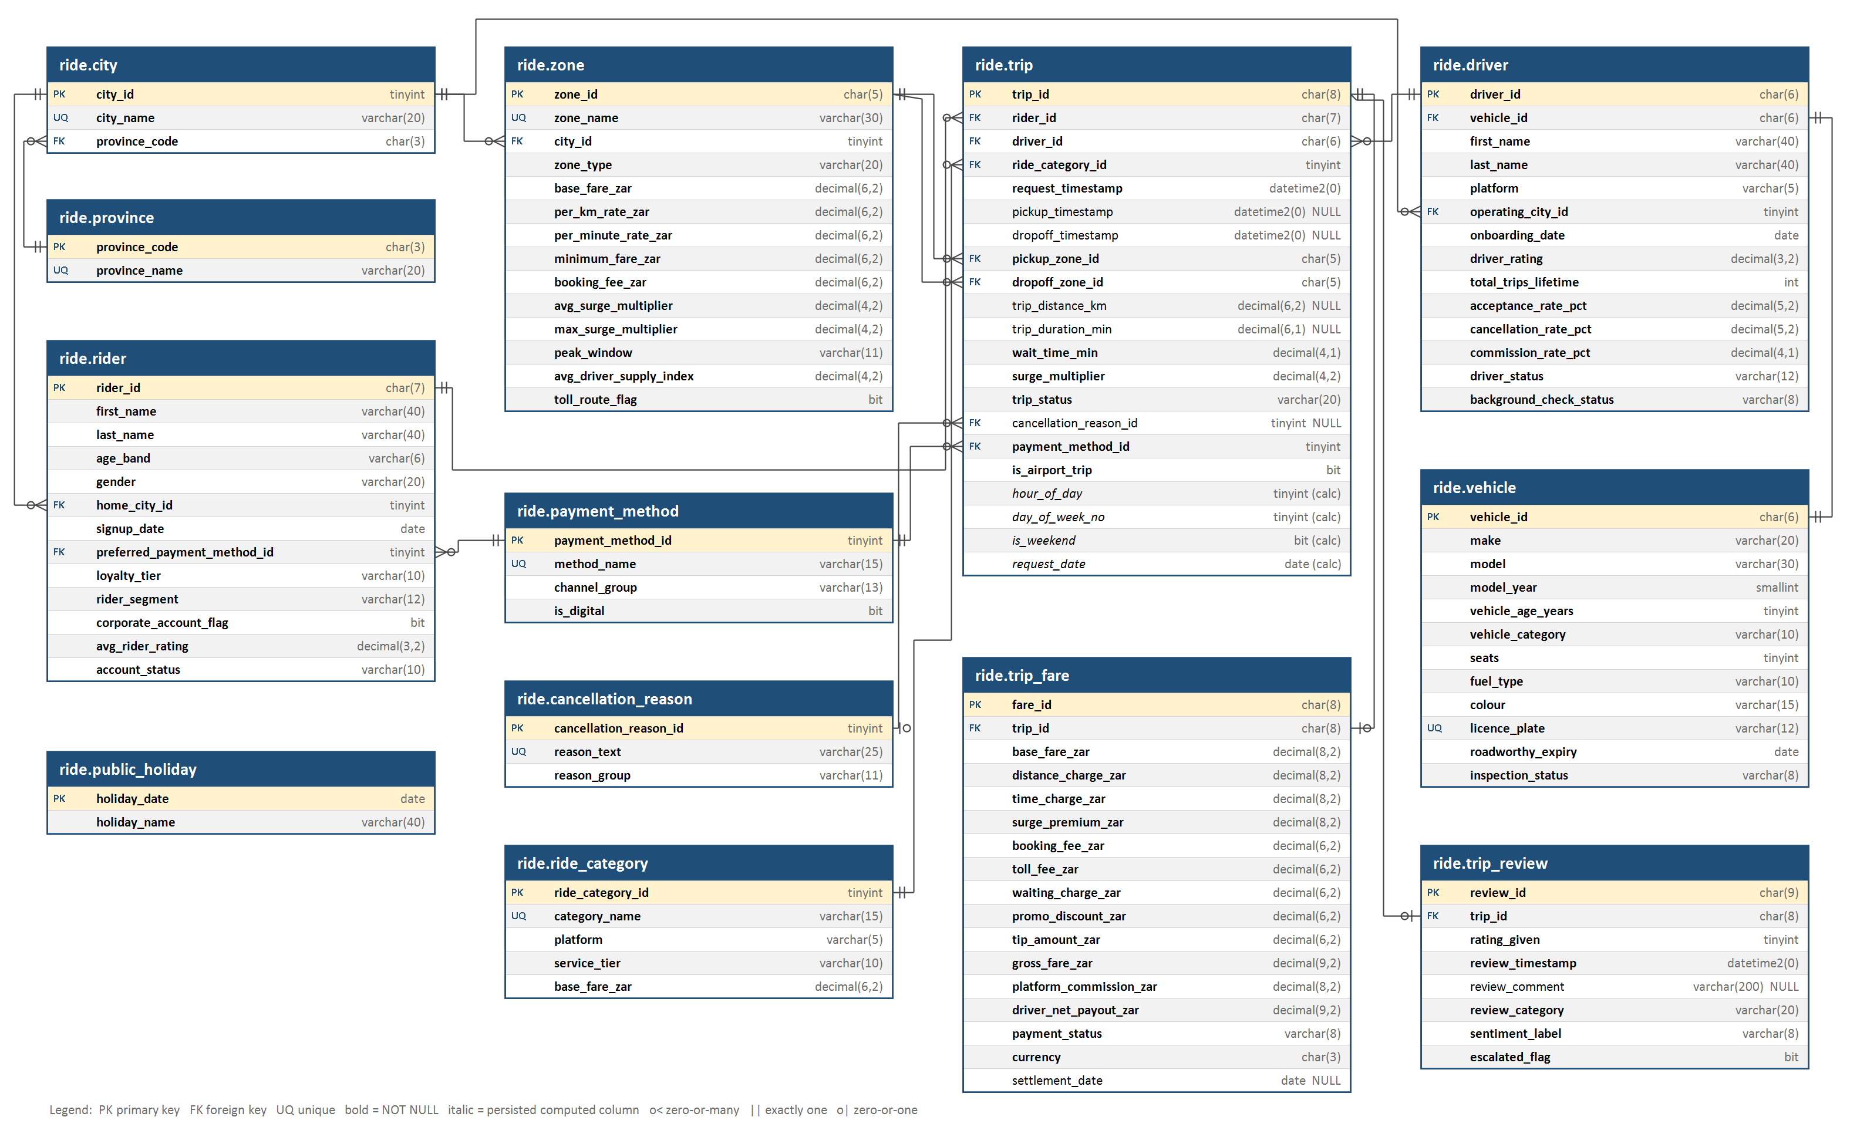
Figure 5.1 - Entity-Relationship Diagram of DormToDorm_RideDB (schema ride) as implemented in SQL Server, generated from the system catalogue

Relationships
Parent (one) | Child (many) | Foreign key | Cardinality | Notes
province | city | province_code | 1 : 1..* | Each metro sits in one province
city | zone | city_id | 1 : 1..* | Every zone belongs to one metro
city | rider | home_city_id | 1 : 0..* | Rider home metro
city | driver | operating_city_id | 1 : 0..* | Driver operating metro
payment_method | rider | preferred_payment_method_id | 1 : 0..* | Stated preference (compared with actual use in RQ4)
rider | trip | rider_id | 1 : 0..* | 52 riders have no trips - outer joins keep them
driver | trip | driver_id | 1 : 0..*
vehicle | driver | vehicle_id (UNIQUE) | 1 : 1 | One driver, one vehicle
zone | trip | pickup_zone_id | 1 : 0..* | Role-playing dimension: zone is joined twice
zone | trip | dropoff_zone_id | 1 : 0..* | Second role of the same dimension
ride_category | trip | ride_category_id | 1 : 0..* | Determines platform and base fare
payment_method | trip | payment_method_id | 1 : 0..* | Instrument actually attempted
cancellation_reason | trip | cancellation_reason_id (NULL) | 0..1 : 0..* | NULL on completed trips
trip | trip_fare | trip_id (UNIQUE) | 1 : 0..1 | Only Completed and Payment Failed trips have a fare
trip | trip_review | trip_id (UNIQUE) | 1 : 0..1 | Reviews are voluntary
Table 5.1 - The 15 foreign keys. public_holiday is a reference table joined on trip.request_date; it has no foreign key because most dates are not holidays.
The full column-level data dictionary, read from the database catalogue, is in Appendix A.

SQL Query Development

Conventions
- Settled revenue is SUM(gross_fare_zar) where payment_status = 'Settled'. A request is any row in trip, whatever its outcome.
- Demand questions use LEFT JOIN to trip_fare so cancelled and unfulfilled requests are counted; spend questions use INNER JOIN so only billed trips contribute.
- Rates are ratios of sums, not averages of per-group ratios, so small groups do not distort totals.
- Zero-inflated measures (tips, promotions, surge premium) are reported as both an attachment rate and an average-when-present.
- One pass over the fact table: conditional aggregation (SUM(CASE ...)) computes several measures in one scan instead of separate filtered queries.

Technique coverage
Query | RQ | Multi-table join | Outer join | GROUP BY / HAVING | CTE / subquery | Window / analytic | GROUPING SETS / PIVOT
Q01 | RQ1 | Y | Y | Y | Y | SUM OVER | GROUPING SETS
Q02 / Q02b | RQ2 | Y (5 tables) | Y | HAVING | Y | RANK, ROW_NUMBER | GROUPING SETS
Q03 | RQ3 | Y | Y | Y | Y |  | GROUPING SETS + GROUPING_ID
Q04 / Q04b | RQ4 | Y (self-role lookup) |  | Y | Y | SUM OVER | PIVOT
Q05 / Q05b | RQ5 | Y |  | HAVING | Y | FIRST_VALUE, LAST_VALUE, LAG, moving AVG
Q06 / Q06b | RQ6 | Y (5 tables) |  |  |  | PERCENTILE_CONT
Q07 | RQ7 | Y |  | Y
Q08 | RQ8 | Y |  | Y | Y (CROSS APPLY) | LAG
Q09 / b / c | RQ9 | Y | Y | HAVING | Y | DENSE_RANK
Q10 / Q10b | RQ10 | Y |  | Y | Y | NTILE, running SUM
Q11 | RQ11 | Y | Y | Y
Q12 | RQ12 | Y |  | Y |  | AVG(AVG()) OVER
Q13 / Q13b | RQ13 | Y (4 tables) |  | Y | Y |  | PIVOT
Q14 | RQ14 | Y |  | Y | Scalar subquery
Q15 | RQ15 | Y (4 tables) | Y | Y |  | SUM(SUM()) OVER
Q16 | RQ16 | Y | Y | Y | Y | LEAD
Q17 / Q17b | RQ17 | Y (4 tables) | Y | Y | Y (2 CTEs) | RANK
Q18 | RQ18 | Y |  | Y | Y | LEAD, SUM OVER
Q19 | RQ19 | Y | Y | Y | Y (4 chained CTEs) | NTILE x3, SUM OVER
Table 6.1 - Advanced SQL techniques per query. Transactions, a trigger, a stored procedure and a view are covered in 6.4.

Query listings
Every query below is in script 04 and runs against the loaded database. Results are presented and interpreted in Section 7.

Theme A - Payment channel adoption and substitution
Q01 | RQ1 - Payment mix: share of requests and settled revenue, per platform and overall
-- Techniques: 4-table join, LEFT OUTER JOIN, conditional aggregation, GROUPING SETS, window SUM() OVER
WITH mix AS (
SELECT p.method_name,
ISNULL(rc.platform, 'All') AS platform,
COUNT(*) AS requests,
SUM(CASE WHEN t.trip_status = 'Completed' THEN 1 ELSE 0 END) AS completed_trips,
SUM(CASE WHEN f.payment_status = 'Settled' THEN f.gross_fare_zar ELSE 0 END) AS settled_revenue_zar
FROM ride.trip t
JOIN ride.payment_method p ON p.payment_method_id = t.payment_method_id
JOIN ride.ride_category rc ON rc.ride_category_id = t.ride_category_id
LEFT JOIN ride.trip_fare f ON f.trip_id = t.trip_id
GROUP BY GROUPING SETS ((p.method_name, rc.platform), (p.method_name))
)
SELECT platform, method_name, requests,
CAST(100.0 * requests / SUM(requests) OVER (PARTITION BY platform) AS DECIMAL(5,2)) AS pct_of_requests,
CAST(100.0 * completed_trips / requests AS DECIMAL(5,2)) AS completion_rate_pct,
settled_revenue_zar,
CAST(100.0 * settled_revenue_zar / SUM(settled_revenue_zar) OVER (PARTITION BY platform) AS DECIMAL(5,2)) AS pct_of_settled_revenue
FROM mix
ORDER BY CASE platform WHEN 'All' THEN 0 WHEN 'Uber' THEN 1 ELSE 2 END, settled_revenue_zar DESC;

Q02 | RQ2 - Cash dependency by city and by pickup-zone type, ranked
-- Techniques: 5-table join (role-playing zone dimension), GROUPING SETS + GROUPING(), HAVING, RANK()
SELECT CASE WHEN GROUPING(c.city_name) = 0 THEN 'City' ELSE 'Zone type' END AS grouping_level,
COALESCE(c.city_name, z.zone_type) AS segment,
COUNT(*) AS requests,
CAST(100.0 * SUM(CASE WHEN p.is_digital = 0 THEN 1 ELSE 0 END) / COUNT(*) AS DECIMAL(5,2)) AS cash_share_pct,
CAST(AVG(z.avg_driver_supply_index) AS DECIMAL(4,2)) AS avg_supply_index,
CAST(AVG(CASE WHEN f.payment_status = 'Settled' THEN f.gross_fare_zar END) AS DECIMAL(8,2)) AS avg_settled_fare_zar,
RANK() OVER (PARTITION BY GROUPING(c.city_name)
ORDER BY 1.0 * SUM(CASE WHEN p.is_digital = 0 THEN 1 ELSE 0 END) / COUNT(*) DESC) AS cash_rank
FROM ride.trip t
JOIN ride.zone z ON z.zone_id = t.pickup_zone_id
JOIN ride.city c ON c.city_id = z.city_id
JOIN ride.payment_method p ON p.payment_method_id = t.payment_method_id
LEFT JOIN ride.trip_fare f ON f.trip_id = t.trip_id
GROUP BY GROUPING SETS ((c.city_name), (z.zone_type))
HAVING COUNT(*) >= 500
ORDER BY grouping_level, cash_rank;

Q02b | RQ2 - Migration readiness per city: cash share vs the failure rate riders would face on digital
-- Techniques: CTE, conditional aggregation over a role split (cash vs digital), derived "readiness" metric, ROW_NUMBER()
WITH city_pay AS (
SELECT c.city_name, pr.province_name,
COUNT(*) AS requests,
SUM(CASE WHEN p.is_digital = 0 THEN 1 ELSE 0 END) AS cash_requests,
SUM(CASE WHEN p.channel_group = 'Card' THEN 1 ELSE 0 END) AS card_requests,
SUM(CASE WHEN p.channel_group = 'Card' AND t.trip_status = 'Payment Failed' THEN 1 ELSE 0 END) AS card_failures,
SUM(CASE WHEN p.channel_group IN ('Mobile Wallet','In-App Wallet') THEN 1 ELSE 0 END) AS wallet_requests,
SUM(CASE WHEN p.channel_group IN ('Mobile Wallet','In-App Wallet') AND t.trip_status = 'Payment Failed' THEN 1 ELSE 0 END) AS wallet_failures
FROM ride.trip t
JOIN ride.zone z ON z.zone_id = t.pickup_zone_id
JOIN ride.city c ON c.city_id = z.city_id
JOIN ride.province pr ON pr.province_code = c.province_code
JOIN ride.payment_method p ON p.payment_method_id = t.payment_method_id
GROUP BY c.city_name, pr.province_name
)
SELECT ROW_NUMBER() OVER (ORDER BY 1.0 * cash_requests / requests DESC) AS priority,
city_name, province_name, requests, cash_requests,
CAST(100.0 * cash_requests / requests AS DECIMAL(5,2)) AS cash_share_pct,
CAST(100.0 * card_failures / NULLIF(card_requests, 0) AS DECIMAL(5,2)) AS card_failure_pct,
CAST(100.0 * wallet_failures / NULLIF(wallet_requests, 0) AS DECIMAL(5,2)) AS wallet_failure_pct,
CAST(1.0 * cash_requests * (1.0 * card_failures / NULLIF(card_requests, 0)
- 1.0 * wallet_failures / NULLIF(wallet_requests, 0)) AS DECIMAL(8,1)) AS failures_avoided_wallet_vs_card
FROM city_pay
ORDER BY priority;

Q03 | RQ3 - Stated vs revealed cash preference by rider demographic (ROLLUP-style grouping sets)
-- Techniques: derived table (pre-aggregated trip behaviour), LEFT JOIN, GROUPING SETS with grand total, GROUPING_ID()
WITH rider_behaviour AS (
SELECT t.rider_id,
COUNT(*) AS requests,
SUM(CASE WHEN p.is_digital = 0 THEN 1 ELSE 0 END) AS cash_requests
FROM ride.trip t
JOIN ride.payment_method p ON p.payment_method_id = t.payment_method_id
GROUP BY t.rider_id
)
SELECT CASE GROUPING_ID(r.age_band, r.loyalty_tier, r.rider_segment, r.gender)
WHEN 7 THEN 'Age band' WHEN 11 THEN 'Loyalty tier' WHEN 13 THEN 'Rider segment'
WHEN 14 THEN 'Gender' ELSE 'All riders' END AS dimension,
COALESCE(r.age_band, r.loyalty_tier, r.rider_segment, r.gender, 'Total') AS dimension_value,
COUNT(*) AS riders,
CAST(100.0 * SUM(CASE WHEN pp.method_name = 'Cash' THEN 1 ELSE 0 END) / COUNT(*) AS DECIMAL(5,2)) AS stated_cash_pref_pct,
CAST(100.0 * SUM(CASE WHEN pp.channel_group = 'Card' THEN 1 ELSE 0 END) / COUNT(*) AS DECIMAL(5,2)) AS stated_card_pref_pct,
CAST(100.0 * SUM(CASE WHEN pp.channel_group IN ('Mobile Wallet','QR Code','In-App Wallet') THEN 1 ELSE 0 END)
/ COUNT(*) AS DECIMAL(5,2)) AS stated_wallet_qr_pref_pct,
CAST(100.0 * SUM(rb.cash_requests) / NULLIF(SUM(rb.requests), 0) AS DECIMAL(5,2)) AS revealed_cash_share_pct
FROM ride.rider r
JOIN ride.payment_method pp ON pp.payment_method_id = r.preferred_payment_method_id
LEFT JOIN rider_behaviour rb ON rb.rider_id = r.rider_id
GROUP BY GROUPING SETS ((r.age_band), (r.loyalty_tier), (r.rider_segment), (r.gender), ())
ORDER BY dimension, dimension_value;

Q04 | RQ4 - Substitution matrix: stated preference (rows) vs instrument actually used (columns), row %
-- Techniques: self-referencing lookup join (payment_method used twice), window SUM, PIVOT operator
WITH pairs AS (
SELECT pp.method_name AS preferred_method, up.method_name AS used_method, COUNT(*) AS n
FROM ride.trip t
JOIN ride.rider r ON r.rider_id = t.rider_id
JOIN ride.payment_method pp ON pp.payment_method_id = r.preferred_payment_method_id
JOIN ride.payment_method up ON up.payment_method_id = t.payment_method_id
GROUP BY pp.method_name, up.method_name
), pct AS (
SELECT preferred_method, used_method,
CAST(100.0 * n / SUM(n) OVER (PARTITION BY preferred_method) AS DECIMAL(5,1)) AS row_pct
FROM pairs
)
SELECT preferred_method, [Cash], [Credit Card], [Debit Card], [In-App Wallet], [SnapScan], [Zapper], [Apple Pay], [Google Pay]
FROM pct
PIVOT (MAX(row_pct) FOR used_method IN ([Cash], [Credit Card], [Debit Card], [In-App Wallet],
[SnapScan], [Zapper], [Apple Pay], [Google Pay])) AS pv
ORDER BY [Cash] DESC;

Q04b | RQ4 - Headline: share of requests made on the stated preferred instrument
SELECT COUNT(*) AS requests,
SUM(CASE WHEN t.payment_method_id = r.preferred_payment_method_id THEN 1 ELSE 0 END) AS on_preferred,
CAST(100.0 * SUM(CASE WHEN t.payment_method_id = r.preferred_payment_method_id THEN 1 ELSE 0 END) / COUNT(*) AS DECIMAL(5,2)) AS match_rate_pct,
CAST(100.0 * SUM(CASE WHEN pp.is_digital = 0 AND up.is_digital = 1 THEN 1 ELSE 0 END) / COUNT(*) AS DECIMAL(5,2)) AS cash_pref_paid_digital_pct,
CAST(100.0 * SUM(CASE WHEN pp.is_digital = 1 AND up.is_digital = 0 THEN 1 ELSE 0 END) / COUNT(*) AS DECIMAL(5,2)) AS digital_pref_paid_cash_pct
FROM ride.trip t
JOIN ride.rider r ON r.rider_id = t.rider_id
JOIN ride.payment_method pp ON pp.payment_method_id = r.preferred_payment_method_id
JOIN ride.payment_method up ON up.payment_method_id = t.payment_method_id;

Q05 | RQ5 - Migration: first vs last instrument for riders who used more than one instrument
-- Techniques: FIRST_VALUE / LAST_VALUE with explicit window frame, COUNT(DISTINCT) filter in CTE, CASE classification
WITH ordered AS (
SELECT t.rider_id,
FIRST_VALUE(p.is_digital) OVER (PARTITION BY t.rider_id ORDER BY t.request_timestamp
ROWS BETWEEN UNBOUNDED PRECEDING AND UNBOUNDED FOLLOWING) AS first_is_digital,
LAST_VALUE(p.is_digital) OVER (PARTITION BY t.rider_id ORDER BY t.request_timestamp
ROWS BETWEEN UNBOUNDED PRECEDING AND UNBOUNDED FOLLOWING) AS last_is_digital
FROM ride.trip t
JOIN ride.payment_method p ON p.payment_method_id = t.payment_method_id
), per_rider AS (
SELECT DISTINCT rider_id, first_is_digital, last_is_digital FROM ordered
), multi AS (
SELECT rider_id FROM ride.trip GROUP BY rider_id HAVING COUNT(DISTINCT payment_method_id) > 1
)
SELECT CASE WHEN pr.first_is_digital = 0 AND pr.last_is_digital = 1 THEN 'Cash -> Digital'
WHEN pr.first_is_digital = 1 AND pr.last_is_digital = 0 THEN 'Digital -> Cash'
WHEN pr.first_is_digital = 0 THEN 'Cash -> Cash'
ELSE 'Digital -> Digital' END AS transition,
COUNT(*) AS riders,
CAST(100.0 * COUNT(*) / SUM(COUNT(*)) OVER () AS DECIMAL(5,2)) AS pct_of_multi_instrument_riders
FROM per_rider pr
JOIN multi m ON m.rider_id = pr.rider_id
GROUP BY CASE WHEN pr.first_is_digital = 0 AND pr.last_is_digital = 1 THEN 'Cash -> Digital'
WHEN pr.first_is_digital = 1 AND pr.last_is_digital = 0 THEN 'Digital -> Cash'
WHEN pr.first_is_digital = 0 THEN 'Cash -> Cash'
ELSE 'Digital -> Digital' END
ORDER BY riders DESC;

Q05b | RQ5 - Monthly cash share trend with month-on-month change
-- Techniques: date truncation, LAG() window, running (cumulative) average window frame
WITH monthly AS (
SELECT DATEFROMPARTS(YEAR(t.request_date), MONTH(t.request_date), 1) AS month_start,
COUNT(*) AS requests,
100.0 * SUM(CASE WHEN p.is_digital = 0 THEN 1 ELSE 0 END) / COUNT(*) AS cash_share_pct
FROM ride.trip t
JOIN ride.payment_method p ON p.payment_method_id = t.payment_method_id
GROUP BY DATEFROMPARTS(YEAR(t.request_date), MONTH(t.request_date), 1)
)
SELECT FORMAT(month_start, 'yyyy-MM') AS month, requests,
CAST(cash_share_pct AS DECIMAL(5,2)) AS cash_share_pct,
CAST(cash_share_pct - LAG(cash_share_pct) OVER (ORDER BY month_start) AS DECIMAL(5,2)) AS mom_change_pp,
CAST(AVG(cash_share_pct) OVER (ORDER BY month_start ROWS BETWEEN 2 PRECEDING AND CURRENT ROW) AS DECIMAL(5,2)) AS rolling_3m_cash_pct
FROM monthly
ORDER BY month_start;

Theme B - Rider spend, basket composition and trip economics
Q06 | RQ6 - Fare distribution per settled trip by province (quartiles, median)
-- Techniques: PERCENTILE_CONT ... WITHIN GROUP ... OVER (PARTITION BY), DISTINCT over window results
SELECT DISTINCT pr.province_name,
COUNT(*) OVER (PARTITION BY pr.province_name) AS settled_trips,
CAST(AVG(f.gross_fare_zar) OVER (PARTITION BY pr.province_name) AS DECIMAL(8,2)) AS mean_fare_zar,
CAST(PERCENTILE_CONT(0.25) WITHIN GROUP (ORDER BY f.gross_fare_zar) OVER (PARTITION BY pr.province_name) AS DECIMAL(8,2)) AS p25_zar,
CAST(PERCENTILE_CONT(0.50) WITHIN GROUP (ORDER BY f.gross_fare_zar) OVER (PARTITION BY pr.province_name) AS DECIMAL(8,2)) AS median_zar,
CAST(PERCENTILE_CONT(0.75) WITHIN GROUP (ORDER BY f.gross_fare_zar) OVER (PARTITION BY pr.province_name) AS DECIMAL(8,2)) AS p75_zar,
CAST(PERCENTILE_CONT(0.90) WITHIN GROUP (ORDER BY f.gross_fare_zar) OVER (PARTITION BY pr.province_name) AS DECIMAL(8,2)) AS p90_zar,
CAST(SUM(f.gross_fare_zar) OVER (PARTITION BY pr.province_name)
/ SUM(t.trip_distance_km) OVER (PARTITION BY pr.province_name) AS DECIMAL(6,2)) AS zar_per_km
FROM ride.trip_fare f
JOIN ride.trip t ON t.trip_id = f.trip_id
JOIN ride.zone z ON z.zone_id = t.pickup_zone_id
JOIN ride.city c ON c.city_id = z.city_id
JOIN ride.province pr ON pr.province_code = c.province_code
WHERE f.payment_status = 'Settled'
ORDER BY median_zar DESC;

Q06b | RQ6 - Fare distribution per settled trip by ride category
SELECT DISTINCT rc.platform, rc.category_name, rc.service_tier,
COUNT(*) OVER (PARTITION BY rc.category_name) AS settled_trips,
CAST(PERCENTILE_CONT(0.25) WITHIN GROUP (ORDER BY f.gross_fare_zar) OVER (PARTITION BY rc.category_name) AS DECIMAL(8,2)) AS p25_zar,
CAST(PERCENTILE_CONT(0.50) WITHIN GROUP (ORDER BY f.gross_fare_zar) OVER (PARTITION BY rc.category_name) AS DECIMAL(8,2)) AS median_zar,
CAST(PERCENTILE_CONT(0.75) WITHIN GROUP (ORDER BY f.gross_fare_zar) OVER (PARTITION BY rc.category_name) AS DECIMAL(8,2)) AS p75_zar,
CAST(AVG(f.gross_fare_zar) OVER (PARTITION BY rc.category_name) AS DECIMAL(8,2)) AS mean_fare_zar
FROM ride.trip_fare f
JOIN ride.trip t ON t.trip_id = f.trip_id
JOIN ride.ride_category rc ON rc.ride_category_id = t.ride_category_id
WHERE f.payment_status = 'Settled'
ORDER BY median_zar;

Q07 | RQ7 - Fare composition (% of gross fare) by service tier
-- Techniques: multi-column aggregation, ratio-of-sums, CROSS APPLY to unpivot components for charting
SELECT rc.service_tier,
COUNT(*) AS settled_trips,
CAST(100.0 * SUM(f.base_fare_zar) / SUM(f.gross_fare_zar) AS DECIMAL(5,2)) AS base_pct,
CAST(100.0 * SUM(f.distance_charge_zar) / SUM(f.gross_fare_zar) AS DECIMAL(5,2)) AS distance_pct,
CAST(100.0 * SUM(f.time_charge_zar) / SUM(f.gross_fare_zar) AS DECIMAL(5,2)) AS time_pct,
CAST(100.0 * SUM(f.surge_premium_zar) / SUM(f.gross_fare_zar) AS DECIMAL(5,2)) AS surge_pct,
CAST(100.0 * SUM(f.booking_fee_zar) / SUM(f.gross_fare_zar) AS DECIMAL(5,2)) AS booking_pct,
CAST(100.0 * SUM(f.toll_fee_zar) / SUM(f.gross_fare_zar) AS DECIMAL(5,2)) AS toll_pct,
CAST(100.0 * SUM(f.waiting_charge_zar) / SUM(f.gross_fare_zar) AS DECIMAL(5,2)) AS waiting_pct,
CAST(100.0 * SUM(f.tip_amount_zar) / SUM(f.gross_fare_zar) AS DECIMAL(5,2)) AS tip_pct,
CAST(-100.0 * SUM(f.promo_discount_zar) / SUM(f.gross_fare_zar) AS DECIMAL(5,2)) AS promo_pct,
CAST(AVG(f.gross_fare_zar) AS DECIMAL(8,2)) AS avg_gross_zar
FROM ride.trip_fare f
JOIN ride.trip t ON t.trip_id = f.trip_id
JOIN ride.ride_category rc ON rc.ride_category_id = t.ride_category_id
WHERE f.payment_status = 'Settled'
GROUP BY rc.service_tier
ORDER BY avg_gross_zar;

Q08 | RQ8 - Spend efficiency (R/km) by distance band, with marginal change between bands
-- Techniques: CASE bucketing inside CROSS APPLY, ratio-of-sums, LAG() to find where R/km stops falling
WITH banded AS (
SELECT b.band_no, b.band_label, t.trip_distance_km, f.gross_fare_zar - f.tip_amount_zar AS fare_ex_tip
FROM ride.trip_fare f
JOIN ride.trip t ON t.trip_id = f.trip_id
CROSS APPLY (SELECT CASE WHEN t.trip_distance_km < 2 THEN 1 WHEN t.trip_distance_km < 5 THEN 2
WHEN t.trip_distance_km < 10 THEN 3 WHEN t.trip_distance_km < 15 THEN 4
WHEN t.trip_distance_km < 20 THEN 5 WHEN t.trip_distance_km < 30 THEN 6
WHEN t.trip_distance_km < 50 THEN 7 ELSE 8 END AS band_no) n
CROSS APPLY (SELECT CHOOSE(n.band_no, '0-2 km','2-5 km','5-10 km','10-15 km','15-20 km','20-30 km','30-50 km','50+ km') AS band_label,
n.band_no) b
WHERE f.payment_status = 'Settled'
)
SELECT band_label, COUNT(*) AS settled_trips,
CAST(AVG(fare_ex_tip) AS DECIMAL(8,2)) AS avg_fare_ex_tip_zar,
CAST(SUM(fare_ex_tip) / SUM(trip_distance_km) AS DECIMAL(6,2)) AS zar_per_km,
CAST(SUM(fare_ex_tip) / SUM(trip_distance_km)
- LAG(SUM(fare_ex_tip) / SUM(trip_distance_km)) OVER (ORDER BY band_no) AS DECIMAL(6,2)) AS change_vs_prev_band
FROM banded
GROUP BY band_no, band_label
ORDER BY band_no;

Q09 | RQ9 - Spend by hour of day (all requests and settled spend)
-- Techniques: persisted computed column (indexed), LEFT JOIN, HAVING minimum volume
SELECT t.hour_of_day,
COUNT(*) AS requests,
SUM(CASE WHEN f.payment_status = 'Settled' THEN 1 ELSE 0 END) AS settled_trips,
CAST(AVG(CASE WHEN f.payment_status = 'Settled' THEN f.gross_fare_zar END) AS DECIMAL(8,2)) AS avg_settled_fare_zar,
CAST(SUM(CASE WHEN f.payment_status = 'Settled' THEN f.gross_fare_zar ELSE 0 END) AS DECIMAL(12,2)) AS settled_revenue_zar,
CAST(AVG(t.surge_multiplier) AS DECIMAL(4,2)) AS avg_surge
FROM ride.trip t
LEFT JOIN ride.trip_fare f ON f.trip_id = t.trip_id
GROUP BY t.hour_of_day
HAVING COUNT(*) >= 100
ORDER BY t.hour_of_day;

Q09b | RQ9 - Top 10 highest-value day x hour windows (minimum 150 settled trips)
-- Techniques: GROUP BY on two computed columns, HAVING, DENSE_RANK(), CHOOSE() for labels
WITH win AS (
SELECT t.day_of_week_no, t.hour_of_day, COUNT(*) AS settled_trips,
AVG(f.gross_fare_zar) AS avg_fare, SUM(f.gross_fare_zar) AS revenue
FROM ride.trip t
JOIN ride.trip_fare f ON f.trip_id = t.trip_id AND f.payment_status = 'Settled'
GROUP BY t.day_of_week_no, t.hour_of_day
HAVING COUNT(*) >= 150
)
SELECT TOP (10)
DENSE_RANK() OVER (ORDER BY revenue DESC) AS revenue_rank,
CHOOSE(day_of_week_no, 'Mon','Tue','Wed','Thu','Fri','Sat','Sun') AS day_name,
FORMAT(hour_of_day, '00') + ':00' AS hour_start,
settled_trips, CAST(avg_fare AS DECIMAL(8,2)) AS avg_fare_zar, CAST(revenue AS DECIMAL(12,2)) AS revenue_zar
FROM win
ORDER BY revenue DESC;

Q09c | RQ9 - Weekday vs weekend vs public holiday (supplementary holiday table)
-- Techniques: LEFT JOIN to supplementary reference table, CASE precedence, per-day normalisation with COUNT(DISTINCT)
SELECT CASE WHEN h.holiday_date IS NOT NULL THEN 'Public holiday'
WHEN t.is_weekend = 1 THEN 'Weekend'
ELSE 'Weekday' END AS day_type,
COUNT(DISTINCT t.request_date) AS calendar_days,
COUNT(*) AS requests,
CAST(1.0 * COUNT(*) / COUNT(DISTINCT t.request_date) AS DECIMAL(8,1)) AS requests_per_day,
CAST(AVG(CASE WHEN f.payment_status = 'Settled' THEN f.gross_fare_zar END) AS DECIMAL(8,2)) AS avg_settled_fare_zar,
CAST(100.0 * SUM(CASE WHEN p.is_digital = 0 THEN 1 ELSE 0 END) / COUNT(*) AS DECIMAL(5,2)) AS cash_share_pct
FROM ride.trip t
JOIN ride.payment_method p ON p.payment_method_id = t.payment_method_id
LEFT JOIN ride.public_holiday h ON h.holiday_date = t.request_date
LEFT JOIN ride.trip_fare f ON f.trip_id = t.trip_id
GROUP BY CASE WHEN h.holiday_date IS NOT NULL THEN 'Public holiday'
WHEN t.is_weekend = 1 THEN 'Weekend'
ELSE 'Weekday' END;

Q10 | RQ10 - Revenue concentration by rider spend decile
-- Techniques: CTE, NTILE(10), window SUM for share and cumulative share
WITH spend AS (
SELECT t.rider_id, SUM(f.gross_fare_zar) AS lifetime_spend, COUNT(*) AS settled_trips
FROM ride.trip t
JOIN ride.trip_fare f ON f.trip_id = t.trip_id
WHERE f.payment_status = 'Settled'
GROUP BY t.rider_id
), dec AS (
SELECT *, NTILE(10) OVER (ORDER BY lifetime_spend DESC) AS spend_decile FROM spend
)
SELECT spend_decile, COUNT(*) AS riders,
CAST(AVG(lifetime_spend) AS DECIMAL(10,2)) AS avg_spend_zar,
CAST(AVG(1.0 * settled_trips) AS DECIMAL(6,1)) AS avg_trips,
CAST(100.0 * SUM(lifetime_spend) / SUM(SUM(lifetime_spend)) OVER () AS DECIMAL(5,2)) AS pct_of_revenue,
CAST(100.0 * SUM(SUM(lifetime_spend)) OVER (ORDER BY spend_decile ROWS UNBOUNDED PRECEDING)
/ SUM(SUM(lifetime_spend)) OVER () AS DECIMAL(5,2)) AS cumulative_pct
FROM dec
GROUP BY spend_decile
ORDER BY spend_decile;

Q10b | RQ10 - Profile of the top decile vs the rest
-- Techniques: CTE reuse, join back to dimension, conditional aggregation, comparison of two cohorts
WITH spend AS (
SELECT t.rider_id, SUM(f.gross_fare_zar) AS lifetime_spend, COUNT(*) AS settled_trips,
SUM(CASE WHEN t.is_airport_trip = 1 THEN 1 ELSE 0 END) AS airport_trips
FROM ride.trip t
JOIN ride.trip_fare f ON f.trip_id = t.trip_id
WHERE f.payment_status = 'Settled'
GROUP BY t.rider_id
), dec AS (
SELECT *, NTILE(10) OVER (ORDER BY lifetime_spend DESC) AS spend_decile FROM spend
)
SELECT CASE WHEN d.spend_decile = 1 THEN 'Top 10%' ELSE 'Other 90%' END AS cohort,
COUNT(*) AS riders,
CAST(AVG(1.0 * d.settled_trips) AS DECIMAL(6,1)) AS avg_trips,
CAST(SUM(d.lifetime_spend) / SUM(d.settled_trips) AS DECIMAL(8,2)) AS avg_fare_zar,
CAST(100.0 * SUM(d.airport_trips) / SUM(d.settled_trips) AS DECIMAL(5,2)) AS airport_trip_pct,
CAST(100.0 * SUM(CASE WHEN r.rider_segment = 'Frequent' THEN 1 ELSE 0 END) / COUNT(*) AS DECIMAL(5,2)) AS frequent_pct,
CAST(100.0 * SUM(CASE WHEN r.rider_segment = 'Corporate' THEN 1 ELSE 0 END) / COUNT(*) AS DECIMAL(5,2)) AS corporate_pct,
CAST(100.0 * SUM(CASE WHEN r.loyalty_tier IN ('Gold','Platinum') THEN 1 ELSE 0 END) / COUNT(*) AS DECIMAL(5,2)) AS gold_plat_pct,
CAST(100.0 * SUM(CASE WHEN pp.is_digital = 0 THEN 1 ELSE 0 END) / COUNT(*) AS DECIMAL(5,2)) AS cash_pref_pct
FROM dec d
JOIN ride.rider r ON r.rider_id = d.rider_id
JOIN ride.payment_method pp ON pp.payment_method_id = r.preferred_payment_method_id
GROUP BY CASE WHEN d.spend_decile = 1 THEN 'Top 10%' ELSE 'Other 90%' END;

Q11 | RQ11 - Airport vs non-airport trips
-- Techniques: LEFT JOIN, conditional aggregates for rates, NULLIF divide-by-zero guard
SELECT CASE t.is_airport_trip WHEN 1 THEN 'Airport' ELSE 'Non-airport' END AS trip_type,
COUNT(*) AS requests,
CAST(AVG(t.trip_distance_km) AS DECIMAL(6,2)) AS avg_km,
CAST(AVG(CASE WHEN f.payment_status = 'Settled' THEN f.gross_fare_zar END) AS DECIMAL(8,2)) AS avg_settled_fare_zar,
CAST(100.0 * SUM(CASE WHEN p.is_digital = 1 THEN 1 ELSE 0 END) / COUNT(*) AS DECIMAL(5,2)) AS digital_share_pct,
CAST(100.0 * SUM(CASE WHEN f.payment_status = 'Settled' AND f.tip_amount_zar > 0 THEN 1 ELSE 0 END)
/ NULLIF(SUM(CASE WHEN f.payment_status = 'Settled' THEN 1 ELSE 0 END), 0) AS DECIMAL(5,2)) AS tip_rate_pct,
CAST(100.0 * SUM(CASE WHEN t.trip_status = 'Payment Failed' THEN 1 ELSE 0 END) / COUNT(*) AS DECIMAL(5,2)) AS payment_fail_pct,
CAST(100.0 * SUM(CASE WHEN t.trip_status = 'Completed' THEN 1 ELSE 0 END) / COUNT(*) AS DECIMAL(5,2)) AS completion_pct
FROM ride.trip t
JOIN ride.payment_method p ON p.payment_method_id = t.payment_method_id
LEFT JOIN ride.trip_fare f ON f.trip_id = t.trip_id
GROUP BY t.is_airport_trip;

Theme C - Tipping behaviour
Q12 | RQ12 - Tip attachment and value by payment method, and impact on driver take-home
-- Techniques: conditional aggregation, zero-inflation handled (avg tip when tipped vs per trip), window AVG baseline
SELECT p.method_name,
COUNT(*) AS settled_trips,
CAST(100.0 * SUM(CASE WHEN f.tip_amount_zar > 0 THEN 1 ELSE 0 END) / COUNT(*) AS DECIMAL(5,2)) AS tip_attach_pct,
CAST(AVG(CASE WHEN f.tip_amount_zar > 0 THEN f.tip_amount_zar END) AS DECIMAL(6,2)) AS avg_tip_when_tipped_zar,
CAST(AVG(f.tip_amount_zar) AS DECIMAL(6,2)) AS avg_tip_per_trip_zar,
CAST(100.0 * SUM(f.tip_amount_zar) / SUM(f.driver_net_payout_zar) AS DECIMAL(5,2)) AS tips_pct_of_driver_payout,
CAST(AVG(f.tip_amount_zar) - AVG(AVG(f.tip_amount_zar)) OVER () AS DECIMAL(6,2)) AS diff_vs_avg_method_zar
FROM ride.trip_fare f
JOIN ride.trip t ON t.trip_id = f.trip_id
JOIN ride.payment_method p ON p.payment_method_id = t.payment_method_id
WHERE f.payment_status = 'Settled'
GROUP BY p.method_name
ORDER BY tip_attach_pct DESC;

Q13 | RQ13 - Tip rate by rating given, controlled for cash vs digital
-- Techniques: 4-table INNER join (only reviewed trips), PIVOT of rating into columns
WITH base AS (
SELECT CASE p.is_digital WHEN 1 THEN 'Digital' ELSE 'Cash' END AS channel,
rv.rating_given,
CASE WHEN f.tip_amount_zar > 0 THEN 100.0 ELSE 0.0 END AS tipped_pct
FROM ride.trip_review rv
JOIN ride.trip t ON t.trip_id = rv.trip_id
JOIN ride.trip_fare f ON f.trip_id = t.trip_id AND f.payment_status = 'Settled'
JOIN ride.payment_method p ON p.payment_method_id = t.payment_method_id
)
SELECT channel,
CAST([1] AS DECIMAL(5,2)) AS rating_1, CAST([2] AS DECIMAL(5,2)) AS rating_2, CAST([3] AS DECIMAL(5,2)) AS rating_3,
CAST([4] AS DECIMAL(5,2)) AS rating_4, CAST([5] AS DECIMAL(5,2)) AS rating_5
FROM base
PIVOT (AVG(tipped_pct) FOR rating_given IN ([1],[2],[3],[4],[5])) pv
ORDER BY channel;

Q13b | RQ13 - Review volume and average tip value by rating
SELECT rv.rating_given, COUNT(*) AS reviewed_trips,
CAST(AVG(f.tip_amount_zar) AS DECIMAL(6,2)) AS avg_tip_zar,
CAST(100.0 * SUM(CASE WHEN f.tip_amount_zar > 0 THEN 1 ELSE 0 END) / COUNT(*) AS DECIMAL(5,2)) AS tip_rate_pct,
CAST(100.0 * SUM(CASE WHEN rv.review_category = 'Pricing & Payment' THEN 1 ELSE 0 END) / COUNT(*) AS DECIMAL(5,2)) AS pricing_payment_review_pct
FROM ride.trip_review rv
JOIN ride.trip_fare f ON f.trip_id = rv.trip_id AND f.payment_status = 'Settled'
GROUP BY rv.rating_given
ORDER BY rv.rating_given;

Q14 | RQ14 - Does surge suppress tipping? Tip rate per surge band vs a no-surge baseline subquery
-- Techniques: CASE bucketing, scalar subquery baseline, index ratio
SELECT CASE WHEN t.surge_multiplier = 1.00 THEN '1 No surge'
WHEN t.surge_multiplier <= 1.25 THEN '2 1.01-1.25'
WHEN t.surge_multiplier <= 1.50 THEN '3 1.26-1.50'
WHEN t.surge_multiplier <= 2.00 THEN '4 1.51-2.00'
ELSE '5 >2.00' END AS surge_band,
COUNT(*) AS settled_trips,
CAST(100.0 * SUM(CASE WHEN f.tip_amount_zar > 0 THEN 1 ELSE 0 END) / COUNT(*) AS DECIMAL(5,2)) AS tip_rate_pct,
CAST(AVG(f.tip_amount_zar) AS DECIMAL(6,2)) AS avg_tip_zar,
CAST(AVG(f.gross_fare_zar) AS DECIMAL(8,2)) AS avg_fare_zar,
CAST((100.0 * SUM(CASE WHEN f.tip_amount_zar > 0 THEN 1 ELSE 0 END) / COUNT(*))
/ (SELECT 100.0 * SUM(CASE WHEN f2.tip_amount_zar > 0 THEN 1 ELSE 0 END) / COUNT(*)
FROM ride.trip_fare f2 JOIN ride.trip t2 ON t2.trip_id = f2.trip_id
WHERE f2.payment_status = 'Settled' AND t2.surge_multiplier = 1.00) AS DECIMAL(5,3)) AS index_vs_no_surge
FROM ride.trip_fare f
JOIN ride.trip t ON t.trip_id = f.trip_id
WHERE f.payment_status = 'Settled'
GROUP BY CASE WHEN t.surge_multiplier = 1.00 THEN '1 No surge'
WHEN t.surge_multiplier <= 1.25 THEN '2 1.01-1.25'
WHEN t.surge_multiplier <= 1.50 THEN '3 1.26-1.50'
WHEN t.surge_multiplier <= 2.00 THEN '4 1.51-2.00'
ELSE '5 >2.00' END
ORDER BY surge_band;

Theme D - Payment failure and revenue leakage
Q15 | RQ15 - Payment failure rate and rand value lost per instrument
-- Techniques: 4-table join incl. LEFT JOIN fact-to-fact, conditional SUMs, window share of total loss.
-- Failed fares carry R0 commission in the data, so lost platform revenue is estimated from the
-- driver's contractual commission rate applied to the commissionable fare (gross less tip and toll).
SELECT p.method_name, p.channel_group,
COUNT(*) AS requests,
SUM(CASE WHEN t.trip_status = 'Payment Failed' THEN 1 ELSE 0 END) AS failed_payments,
CAST(100.0 * SUM(CASE WHEN t.trip_status = 'Payment Failed' THEN 1 ELSE 0 END) / COUNT(*) AS DECIMAL(5,2)) AS failure_rate_pct,
CAST(SUM(CASE WHEN f.payment_status = 'Failed' THEN f.gross_fare_zar ELSE 0 END) AS DECIMAL(12,2)) AS value_lost_zar,
CAST(SUM(CASE WHEN f.payment_status = 'Failed'
THEN (f.gross_fare_zar - f.tip_amount_zar - f.toll_fee_zar) * d.commission_rate_pct / 100
ELSE 0 END) AS DECIMAL(12,2)) AS est_commission_lost_zar,
CAST(100.0 * SUM(CASE WHEN f.payment_status = 'Failed' THEN f.gross_fare_zar ELSE 0 END)
/ SUM(SUM(CASE WHEN f.payment_status = 'Failed' THEN f.gross_fare_zar ELSE 0 END)) OVER () AS DECIMAL(5,2)) AS pct_of_total_loss
FROM ride.trip t
JOIN ride.payment_method p ON p.payment_method_id = t.payment_method_id
JOIN ride.driver d ON d.driver_id = t.driver_id
LEFT JOIN ride.trip_fare f ON f.trip_id = t.trip_id
GROUP BY p.method_name, p.channel_group
ORDER BY failure_rate_pct DESC;

Q16 | RQ16 - What riders do in the 30 days after a payment failure (vs after a completed trip)
-- Techniques: LEAD() over each rider's ordered history, DATEDIFF, outcome classification, cohort comparison
WITH hist AS (
SELECT t.rider_id, t.trip_status, t.payment_method_id, t.request_timestamp,
LEAD(t.request_timestamp) OVER (PARTITION BY t.rider_id ORDER BY t.request_timestamp) AS next_ts,
LEAD(t.payment_method_id) OVER (PARTITION BY t.rider_id ORDER BY t.request_timestamp) AS next_pm
FROM ride.trip t
), classified AS (
SELECT h.trip_status,
CASE WHEN h.next_ts IS NULL OR DATEDIFF(DAY, h.request_timestamp, h.next_ts) > 30 THEN 'No trip within 30 days'
WHEN h.next_pm = h.payment_method_id THEN 'Returned - same instrument'
WHEN np.is_digital = 0 THEN 'Returned - switched to cash'
ELSE 'Returned - switched to other digital' END AS outcome
FROM hist h
LEFT JOIN ride.payment_method np ON np.payment_method_id = h.next_pm
WHERE h.trip_status IN ('Payment Failed', 'Completed')
AND h.request_timestamp < '2026-06-01' -- leave a full 30-day observation window
)
SELECT trip_status AS after_event, outcome, COUNT(*) AS events,
CAST(100.0 * COUNT(*) / SUM(COUNT(*)) OVER (PARTITION BY trip_status) AS DECIMAL(5,2)) AS pct_of_events
FROM classified
GROUP BY trip_status, outcome
ORDER BY trip_status DESC, outcome;

Q17 | RQ17 - Zones where surge drives rider cancellations, and the revenue that walks away
-- Techniques: CTEs, 4-table join, filtered aggregation via reason_group, correlated estimate of lost value, RANK()
WITH zone_stats AS (
SELECT z.zone_id, z.zone_name, c.city_name, z.zone_type, z.avg_driver_supply_index,
COUNT(*) AS requests,
AVG(t.surge_multiplier) AS avg_surge,
SUM(CASE WHEN t.trip_status = 'Cancelled by Rider' AND cr.reason_group = 'Price' THEN 1 ELSE 0 END) AS surge_rider_cancels,
SUM(CASE WHEN t.trip_status = 'No Driver Found' THEN 1 ELSE 0 END) AS no_supply_events
FROM ride.trip t
JOIN ride.zone z ON z.zone_id = t.pickup_zone_id
JOIN ride.city c ON c.city_id = z.city_id
LEFT JOIN ride.cancellation_reason cr ON cr.cancellation_reason_id = t.cancellation_reason_id
GROUP BY z.zone_id, z.zone_name, c.city_name, z.zone_type, z.avg_driver_supply_index
), zone_fare AS (
SELECT t.pickup_zone_id, AVG(f.gross_fare_zar) AS avg_settled_fare
FROM ride.trip t JOIN ride.trip_fare f ON f.trip_id = t.trip_id
WHERE f.payment_status = 'Settled'
GROUP BY t.pickup_zone_id
)
SELECT TOP (10)
RANK() OVER (ORDER BY zs.surge_rider_cancels * zf.avg_settled_fare DESC) AS loss_rank,
zs.zone_name, zs.city_name, zs.zone_type, zs.requests,
CAST(zs.avg_surge AS DECIMAL(4,2)) AS avg_surge,
zs.surge_rider_cancels,
CAST(100.0 * zs.surge_rider_cancels / zs.requests AS DECIMAL(5,2)) AS surge_cancel_rate_pct,
zs.avg_driver_supply_index AS supply_index,
CAST(zs.surge_rider_cancels * zf.avg_settled_fare AS DECIMAL(12,2)) AS est_revenue_lost_zar
FROM zone_stats zs
JOIN zone_fare zf ON zf.pickup_zone_id = zs.zone_id
ORDER BY loss_rank;

Q17b | RQ17 - Rider surge-cancellation rate by surge band (price elasticity signal)
SELECT CASE WHEN t.surge_multiplier = 1.00 THEN '1 No surge'
WHEN t.surge_multiplier <= 1.25 THEN '2 1.01-1.25'
WHEN t.surge_multiplier <= 1.50 THEN '3 1.26-1.50'
WHEN t.surge_multiplier <= 2.00 THEN '4 1.51-2.00'
ELSE '5 >2.00' END AS surge_band,
COUNT(*) AS requests,
CAST(100.0 * SUM(CASE WHEN t.trip_status = 'Cancelled by Rider' AND t.cancellation_reason_id = 1 THEN 1 ELSE 0 END)
/ COUNT(*) AS DECIMAL(5,2)) AS rider_surge_cancel_pct,
CAST(100.0 * SUM(CASE WHEN t.trip_status = 'Completed' THEN 1 ELSE 0 END) / COUNT(*) AS DECIMAL(5,2)) AS completion_pct
FROM ride.trip t
GROUP BY CASE WHEN t.surge_multiplier = 1.00 THEN '1 No surge'
WHEN t.surge_multiplier <= 1.25 THEN '2 1.01-1.25'
WHEN t.surge_multiplier <= 1.50 THEN '3 1.26-1.50'
WHEN t.surge_multiplier <= 2.00 THEN '4 1.51-2.00'
ELSE '5 >2.00' END
ORDER BY surge_band;

Theme E - Promotions and rider retention
Q18 | RQ18 - Promotions: penetration, cost and whether discounted riders return sooner
-- Techniques: LEAD() over settled history, DATEDIFF, cohort comparison, EXISTS-free conditional logic
WITH settled AS (
SELECT t.rider_id, t.request_timestamp, f.gross_fare_zar, f.promo_discount_zar,
CASE WHEN f.promo_discount_zar > 0 THEN 'Discounted' ELSE 'Full price' END AS cohort,
LEAD(t.request_timestamp) OVER (PARTITION BY t.rider_id ORDER BY t.request_timestamp) AS next_trip_ts
FROM ride.trip t
JOIN ride.trip_fare f ON f.trip_id = t.trip_id
WHERE f.payment_status = 'Settled'
)
SELECT cohort,
COUNT(*) AS settled_trips,
CAST(100.0 * COUNT(*) / SUM(COUNT(*)) OVER () AS DECIMAL(5,2)) AS pct_of_trips,
CAST(SUM(promo_discount_zar) AS DECIMAL(12,2)) AS promo_cost_zar,
CAST(AVG(CASE WHEN promo_discount_zar > 0 THEN promo_discount_zar END) AS DECIMAL(6,2)) AS avg_discount_zar,
CAST(AVG(gross_fare_zar) AS DECIMAL(8,2)) AS avg_fare_zar,
CAST(AVG(1.0 * DATEDIFF(HOUR, request_timestamp, next_trip_ts)) / 24 AS DECIMAL(6,2)) AS avg_days_to_next_trip,
CAST(100.0 * SUM(CASE WHEN DATEDIFF(DAY, request_timestamp, next_trip_ts) <= 30 THEN 1 ELSE 0 END)
/ SUM(CASE WHEN request_timestamp < '2026-06-01' THEN 1 ELSE 0 END) AS DECIMAL(5,2)) AS repeat_within_30d_pct
FROM settled
GROUP BY cohort;

Q19 | RQ19 - RFM segmentation and payment behaviour per segment
-- Techniques: chained CTEs, NTILE(5) scoring on R/F/M, CASE segment rules, LEFT JOIN of failure history
DECLARE @as_of DATE = '2026-07-01';
WITH rfm_raw AS (
SELECT t.rider_id,
DATEDIFF(DAY, MAX(t.request_timestamp), @as_of) AS recency_days,
COUNT(*) AS frequency,
SUM(f.gross_fare_zar) AS monetary
FROM ride.trip t
JOIN ride.trip_fare f ON f.trip_id = t.trip_id AND f.payment_status = 'Settled'
GROUP BY t.rider_id
), scored AS (
SELECT *,
NTILE(5) OVER (ORDER BY recency_days DESC) AS r_score, -- 5 = most recent
NTILE(5) OVER (ORDER BY frequency) AS f_score, -- 5 = most frequent
NTILE(5) OVER (ORDER BY monetary) AS m_score -- 5 = highest spend
FROM rfm_raw
), segmented AS (
SELECT *,
CASE WHEN r_score >= 4 AND f_score >= 4 AND m_score >= 4 THEN '1 Champions'
WHEN f_score >= 4 AND m_score >= 3 THEN '2 Loyal high-value'
WHEN r_score >= 4 AND f_score <= 2 THEN '3 New / promising'
WHEN r_score <= 2 AND f_score >= 3 THEN '4 At risk'
WHEN r_score <= 2 AND f_score <= 2 THEN '5 Hibernating'
ELSE '6 Needs attention' END AS rfm_segment
FROM scored
), behaviour AS (
SELECT t.rider_id,
COUNT(*) AS requests,
SUM(CASE WHEN p.is_digital = 0 THEN 1 ELSE 0 END) AS cash_requests,
SUM(CASE WHEN t.trip_status = 'Payment Failed' THEN 1 ELSE 0 END) AS failed
FROM ride.trip t JOIN ride.payment_method p ON p.payment_method_id = t.payment_method_id
GROUP BY t.rider_id
)
SELECT s.rfm_segment, COUNT(*) AS riders,
CAST(AVG(1.0 * s.recency_days) AS DECIMAL(6,1)) AS avg_recency_days,
CAST(AVG(1.0 * s.frequency) AS DECIMAL(6,1)) AS avg_trips,
CAST(AVG(s.monetary) AS DECIMAL(10,2)) AS avg_spend_zar,
CAST(100.0 * SUM(s.monetary) / SUM(SUM(s.monetary)) OVER () AS DECIMAL(5,2)) AS pct_of_revenue,
CAST(100.0 * SUM(b.cash_requests) / SUM(b.requests) AS DECIMAL(5,2)) AS cash_share_pct,
CAST(100.0 * SUM(b.failed) / SUM(b.requests) AS DECIMAL(5,2)) AS payment_fail_pct
FROM segmented s
LEFT JOIN behaviour b ON b.rider_id = s.rider_id
GROUP BY s.rfm_segment
ORDER BY s.rfm_segment;

Transactions and programmability
Script 05 adds database objects that enforce rules and protect concurrent updates.

Stored procedure: retry a failed payment as one unit of work
A Payment Failed request was declined at pre-authorisation, so the trip never ran. When the rider retries on a different instrument and the trip goes ahead, three things must change together: the trip becomes Completed with its execution details, the payment method changes, and the fare is settled with commission and payout calculated from the driver's rate. The procedure does this inside one transaction. UPDLOCK and HOLDLOCK on the trip row stop two concurrent retries of the same trip from both settling it (a lost update).
CREATE OR ALTER PROCEDURE ride.usp_retry_failed_payment
@trip_id CHAR(8),
@new_method_name VARCHAR(15),
@pickup_timestamp DATETIME2(0),
@dropoff_timestamp DATETIME2(0),
@trip_distance_km DECIMAL(6,2),
@settlement_date DATE = NULL
AS
BEGIN
SET NOCOUNT ON;
SET XACT_ABORT ON;
SET @settlement_date = COALESCE(@settlement_date, CAST(SYSDATETIME() AS DATE));

DECLARE @pm_id TINYINT, @status VARCHAR(20), @rate DECIMAL(4,1);

BEGIN TRY
BEGIN TRANSACTION;

SELECT @status = t.trip_status, @rate = d.commission_rate_pct
FROM ride.trip t WITH (UPDLOCK, HOLDLOCK)
JOIN ride.driver d ON d.driver_id = t.driver_id
WHERE t.trip_id = @trip_id;

IF @status IS NULL THROW 50020, 'Trip does not exist.', 1;
IF @status <> 'Payment Failed' THROW 50021, 'Only trips with status Payment Failed can be retried.', 1;

SELECT @pm_id = payment_method_id FROM ride.payment_method WHERE method_name = @new_method_name;
IF @pm_id IS NULL THROW 50022, 'Unknown payment method.', 1;

-- Trip first, then fare: the trigger validates the final consistent state
UPDATE ride.trip
SET trip_status = 'Completed',
cancellation_reason_id = NULL,
payment_method_id = @pm_id,
pickup_timestamp = @pickup_timestamp,
dropoff_timestamp = @dropoff_timestamp,
trip_distance_km = @trip_distance_km,
trip_duration_min = CAST(DATEDIFF(SECOND, @pickup_timestamp, @dropoff_timestamp) / 60.0 AS DECIMAL(6,1))
WHERE trip_id = @trip_id;

UPDATE ride.trip_fare
SET payment_status = 'Settled',
settlement_date = @settlement_date,
platform_commission_zar = ROUND((gross_fare_zar - tip_amount_zar - toll_fee_zar) * @rate / 100, 2),
driver_net_payout_zar = gross_fare_zar - ROUND((gross_fare_zar - tip_amount_zar - toll_fee_zar) * @rate / 100, 2)
WHERE trip_id = @trip_id;

COMMIT TRANSACTION;
END TRY
BEGIN CATCH
IF @@TRANCOUNT > 0 ROLLBACK TRANSACTION;
THROW;
END CATCH
END;

Trigger: a cross-table rule CHECK cannot express
CREATE OR ALTER TRIGGER ride.trg_trip_fare_status_guard
ON ride.trip_fare
AFTER INSERT, UPDATE
AS
BEGIN
SET NOCOUNT ON;
IF EXISTS (
SELECT 1
FROM inserted i
JOIN ride.trip t ON t.trip_id = i.trip_id
WHERE NOT ((t.trip_status = 'Completed' AND i.payment_status = 'Settled')
OR (t.trip_status = 'Payment Failed' AND i.payment_status = 'Failed'))
)
BEGIN
THROW 50010, 'Fare payment_status is inconsistent with the trip status.', 1;
END
END;

Demonstration (rolled back)
The demonstration in script 05 runs the procedure inside an outer transaction, attempts an invalid write after a savepoint, then rolls everything back. Captured output:
Step | trip_status | Method | Payment status | Gross fare | Commission | Driver payout | Settled
4a Before | Payment Failed | Debit Card | Failed | R84.81 | R0.00 | R0.00 | -
4b After procedure (in transaction) | Completed | In-App Wallet | Settled | R84.81 | R21.20 | R63.61 | 2026-07-02
4c Invalid write after savepoint | Blocked by trigger: "Fare payment_status is inconsistent with the trip status."
4d After ROLLBACK | Payment Failed | Debit Card | Failed | R84.81 | R0.00 | R0.00 | -
4e Retry a completed trip | Refused: "Only trips with status Payment Failed can be retried."
Table 6.2 - Trip T0000173 through the transaction demonstration. Commission R21.20 = 25% Uber rate on the commissionable fare.
The demonstration also shows the ACID properties at work: atomicity (4d restores every column), consistency (the CHECK constraint ck_trip_completed_cols refused an earlier version of the procedure that did not supply pickup data, and the trigger refuses 4c), and isolation (the update locks held until commit).

Reporting view
ride.v_trip_payment flattens the star into one row per request for ad-hoc analysis and the video demo. It uses LEFT JOINs to trip_fare and cancellation_reason so that unfulfilled requests are not lost.
CREATE OR ALTER VIEW ride.v_trip_payment
AS
SELECT t.trip_id, t.rider_id, t.driver_id, rc.platform, rc.category_name, rc.service_tier,
t.request_timestamp, t.request_date, t.hour_of_day, t.day_of_week_no, t.is_weekend, t.is_airport_trip,
pz.zone_name AS pickup_zone, pz.zone_type AS pickup_zone_type, c.city_name, pr.province_name,
t.trip_status, cr.reason_text AS cancellation_reason, cr.reason_group,
p.method_name AS payment_method, p.channel_group, p.is_digital,
t.trip_distance_km, t.surge_multiplier,
f.gross_fare_zar, f.tip_amount_zar, f.promo_discount_zar, f.platform_commission_zar,
f.driver_net_payout_zar, f.payment_status
FROM ride.trip t
JOIN ride.ride_category rc ON rc.ride_category_id = t.ride_category_id
JOIN ride.zone pz ON pz.zone_id = t.pickup_zone_id
JOIN ride.city c ON c.city_id = pz.city_id
JOIN ride.province pr ON pr.province_code = c.province_code
JOIN ride.payment_method p ON p.payment_method_id = t.payment_method_id
LEFT JOIN ride.cancellation_reason cr ON cr.cancellation_reason_id = t.cancellation_reason_id
LEFT JOIN ride.trip_fare f ON f.trip_id = t.trip_id; -- outer join keeps cancelled requests

Optimisation
Script 06 runs each test twice on a warm cache: once forced onto the base table (or with a non-SARGable predicate), once as designed. Logical reads are the number of 8 KB pages SQL Server touched.
Test | Query | Without optimisation | With optimisation | Reduction | Technique
T1 | One rider's ordered trip history | 777 reads, 12 ms | 4 reads, <1 ms | 99.5% | Composite index (rider_id, request_timestamp) returns rows already sorted
T2 | Surge-friction rider cancellations by zone | 777 reads, 12 ms | 11 reads, 2 ms | 98.6% | Filtered index on the 18% of non-completed trips
T3 | Fare component totals over 50 431 fares | 659 reads, 71-95 ms | 59 LOB reads, <5 ms | 91.0% | Non-clustered columnstore, batch mode
T4 | Requests at 17:00 on Wednesdays | 358 reads, 17 ms | 7 reads, <1 ms | 98.0% | Persisted computed columns make the predicate SARGable
Table 6.3 - Measured effect of the indexing design (SET STATISTICS IO / TIME)
Further optimisations applied in the query set:
- SARGable predicates. Filters compare columns directly (hour_of_day = 17, request_timestamp < '2026-06-01') instead of wrapping them in functions.
- Filter before join. Conditions such as f.payment_status = 'Settled' sit in the JOIN ... ON clause or WHERE clause so rows are discarded before aggregation.
- Single-scan conditional aggregation replaces UNIONs of separately filtered queries (Q01, Q11, Q15).
- Pre-aggregation in CTEs (Q03, Q17, Q19) reduces the 60 000-row fact to one row per rider or zone before it is joined to a dimension.
- Narrow keys. TINYINT lookup keys keep every non-clustered index on trip small.
- Statistics. sp_updatestats runs after the bulk load so cardinality estimates reflect the final data.

Analysis and Reporting
All figures below come from the queries in Section 6, run against the full dataset: 60 000 requests, 49 049 settled trips and R7 024 628 of settled revenue between 1 July 2025 and 30 June 2026.

Theme A - Payment channel adoption and substitution

RQ1 - Payment mix
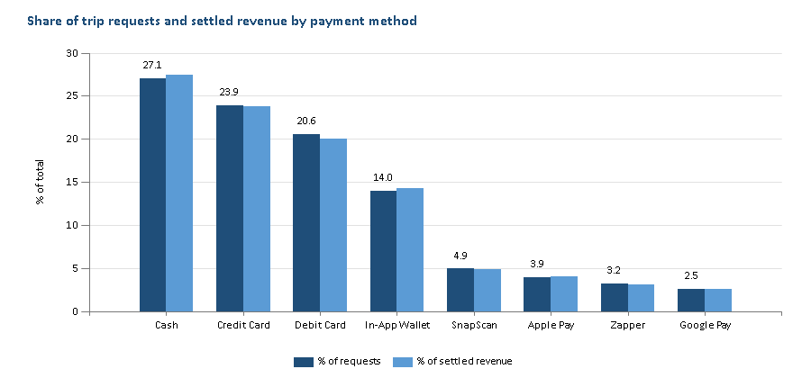
Figure 7.1 - Payment mix (Q01)
Payment method | Requests | % requests | Completion % | Settled revenue | % revenue | Uber % req. | Bolt % req.
Cash | 16 232 | 27.05% | 82.76% | R1 925 354 | 27.41% | 27.15% | 26.95%
Credit Card | 14 334 | 23.89% | 81.04% | R1 671 200 | 23.79% | 23.53% | 24.30%
Debit Card | 12 339 | 20.57% | 80.01% | R1 405 114 | 20.00% | 21.02% | 20.04%
In-App Wallet | 8 378 | 13.96% | 82.67% | R999 685 | 14.23% | 13.75% | 14.21%
SnapScan | 2 953 | 4.92% | 82.22% | R340 277 | 4.84% | 4.94% | 4.90%
Apple Pay | 2 339 | 3.90% | 83.24% | R283 483 | 4.04% | 3.92% | 3.87%
Zapper | 1 904 | 3.17% | 82.35% | R218 310 | 3.11% | 3.16% | 3.18%
Google Pay | 1 521 | 2.54% | 82.77% | R181 206 | 2.58% | 2.53% | 2.54%
Table 7.1 - Payment mix overall and by platform
Cash is the single largest instrument at 27.05% of requests and 27.41% of settled revenue. Cards together account for 44.46% of requests. Revenue share tracks request share closely for every instrument, confirming the Phase 1 observation that instrument choice does not change basket size. The mix is almost identical on Uber and Bolt (no instrument differs by more than one percentage point), so a migration programme does not need platform-specific design.
Completion rates are where the instruments separate: debit card completes 80.01% of requests against 83.24% for Apple Pay - a gap explained by payment failure (RQ15).

RQ2 - Where cash dependency is concentrated
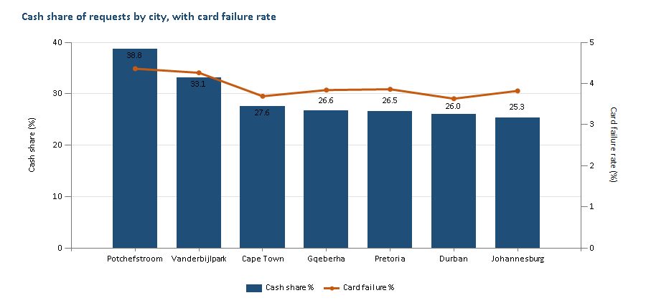
Figure 7.2 - Cash share and card failure rate by city (Q02b)
City | Province | Requests | Cash share | Card failure | Wallet failure | Failures avoided if cash moved to wallet not card
Potchefstroom | North West | 2 279 | 38.75% | 4.36% | 1.38% | 26
Vanderbijlpark | Gauteng | 2 807 | 33.10% | 4.26% | 1.78% | 23
Cape Town | Western Cape | 11 933 | 27.55% | 3.69% | 1.56% | 70
Gqeberha | Eastern Cape | 4 822 | 26.63% | 3.84% | 1.82% | 26
Pretoria | Gauteng | 9 217 | 26.53% | 3.86% | 1.32% | 62
Durban | KwaZulu-Natal | 10 334 | 26.01% | 3.63% | 1.14% | 67
Johannesburg | Gauteng | 18 608 | 25.34% | 3.82% | 1.50% | 109
Table 7.2 - Migration readiness by city (Q02b)
The two smallest metros are the most cash-dependent: Potchefstroom (38.75%) and Vanderbijlpark (33.10%) sit 8-13 points above Johannesburg (25.34%). Both also have the highest card failure rates in the dataset (4.36% and 4.26%), so a rider there who tries a card has the worst experience on the platform. Potchefstroom is a student town and both cities have lower average fares (R102 and R108), consistent with a younger, lower-income rider base.
By pickup zone type the spread is narrow (25.8%-28.2%), with Retail Hub and Township zones highest and Business Districts lowest. City is a far stronger targeting variable than zone type.

RQ3 - Who prefers cash
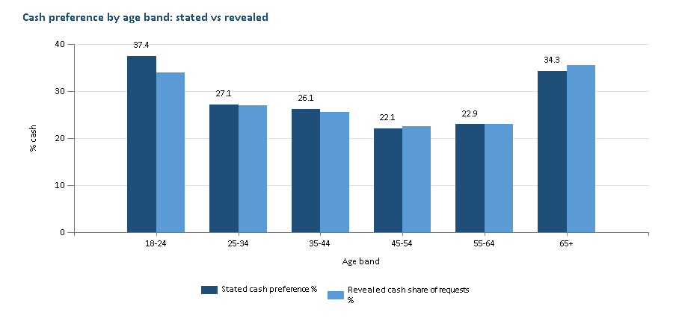
Figure 7.3 - Stated and revealed cash preference by age band (Q03)
Dimension | Value | Riders | Stated cash | Stated card | Stated wallet / QR | Revealed cash share
All riders | Total | 3 200 | 27.88% | 44.22% | 27.91% | 27.05%
Gender | Female | 1 536 | 27.15% | 45.96% | 26.89% | 26.89%
Gender | Male | 1 586 | 28.44% | 42.62% | 28.94% | 27.01%
Gender | Other/Undisclosed | 78 | 30.77% | 42.31% | 26.92% | 30.63%
Loyalty tier | Bronze | 1 679 | 27.70% | 44.13% | 28.17% | 26.74%
Loyalty tier | Gold | 465 | 23.66% | 44.52% | 31.83% | 25.43%
Loyalty tier | Platinum | 155 | 28.39% | 43.23% | 28.39% | 26.96%
Loyalty tier | Silver | 901 | 30.30% | 44.40% | 25.31% | 28.46%
Rider segment | Corporate | 222 | 4.05% | 72.52% | 23.42% | 9.93%
Rider segment | Frequent | 785 | 29.94% | 40.38% | 29.68% | 28.60%
Rider segment | Occasional | 200 | 32.50% | 42.50% | 25.00% | 29.70%
Rider segment | Standard | 1 993 | 29.25% | 42.75% | 28.00% | 28.86%
Table 7.3 - Stated preference and revealed behaviour by rider attributes (Q03, GROUPING SETS)
Age is the clearest demographic signal. Riders aged 18-24 state a cash preference of 37.35% and pay cash on 33.88% of requests; cash preference then falls with each band to 22.05% at 45-54 before rising again for 65+ (a small group of 70 riders). Interest in wallets and QR codes is flat across ages at 26-29%, so younger riders are not choosing cash over wallets - they are choosing cash over cards, which points to bank-card access rather than attitude.
Corporate riders are the exception that proves the rule: only 4.05% state cash. Gender and loyalty tier make little difference (all within about four points of the 27.88% average).

RQ4 - Stated vs revealed preference
Preferred \ Used | Cash | Credit Card | Debit Card | In-App Wallet | SnapScan | Zapper | Apple Pay | Google Pay
Cash | 81.0 | 6.4 | 5.3 | 3.5 | 1.3 | 0.8 | 1.0 | 0.7
Zapper | 7.5 | 6.7 | 5.0 | 3.1 | 1.2 | 74.6 | 1.4 | 0.5
Apple Pay | 7.3 | 6.1 | 5.0 | 3.5 | 1.6 | 1.1 | 74.7 | 0.7
Google Pay | 7.0 | 5.9 | 5.1 | 3.7 | 1.1 | 0.7 | 0.7 | 75.8
Credit Card | 6.9 | 80.1 | 6.1 | 3.3 | 1.2 | 0.7 | 1.1 | 0.7
Debit Card | 6.9 | 6.5 | 79.5 | 3.3 | 1.2 | 0.7 | 1.1 | 0.8
SnapScan | 6.9 | 6.6 | 5.1 | 3.3 | 75.3 | 0.8 | 1.3 | 0.7
In-App Wallet | 6.7 | 6.1 | 5.5 | 77.7 | 1.4 | 0.8 | 1.3 | 0.6
Table 7.4 - Substitution matrix, row % of requests (Q04, PIVOT)
Riders use their stated preferred instrument on 79.15% of requests. When they substitute, the flow is symmetrical: 5.15% of all requests are cash-preferring riders paying digitally, and 5.03% are digital-preferring riders paying cash. Cash is the most common fallback for every non-cash preference (6.7-7.5% of their requests), so cash functions as the safety net when a digital instrument is unavailable or fails.

RQ5 - Is there organic migration?
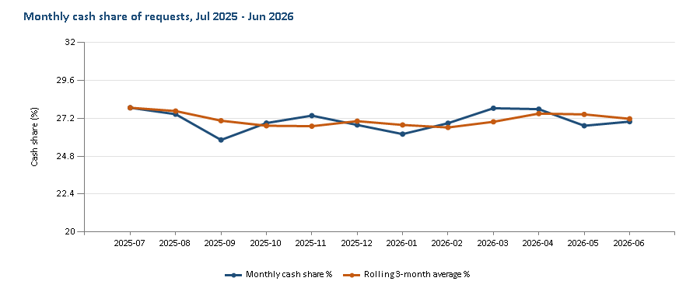
Figure 7.4 - Monthly cash share with rolling three-month average (Q05b)
First -> last instrument | Riders | % of multi-instrument riders
Digital -> Digital | 1 805 | 63.02%
Cash -> Cash | 493 | 17.21%
Cash -> Digital | 284 | 9.92%
Digital -> Cash | 282 | 9.85%
Table 7.5 - First vs last instrument per rider (Q05, FIRST_VALUE / LAST_VALUE)
No. Monthly cash share moved between 25.83% and 27.87% with no trend, and the rolling average ended the year where it began. Among the 2 864 riders who used more than one instrument, 284 started on cash and ended on digital while 282 moved the other way.
Insight: cash is a stable 27% of demand, concentrated in younger riders and the smaller metros, and acts as the fallback when digital fails. Migration will not happen on its own; it must be designed, targeted and paired with a more reliable digital instrument.

Theme B - Rider spend, basket composition and trip economics

RQ6 - Fare distribution by province and category
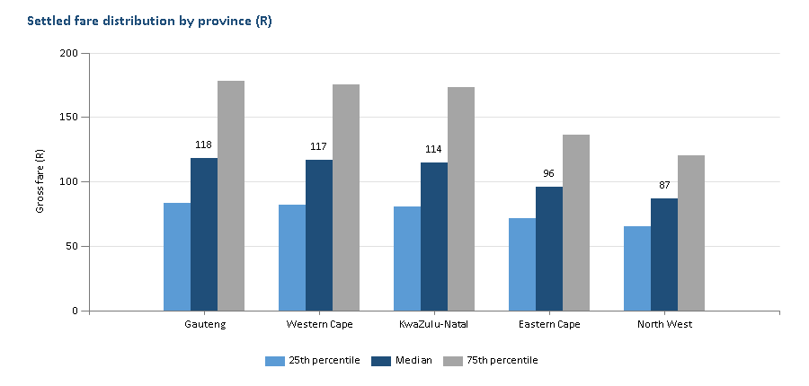
Figure 7.5 - Quartiles of settled fare by province (Q06, PERCENTILE_CONT)
Province | Settled trips | Mean | P25 | Median | P75 | P90 | R per km
Gauteng | 25 061 | R149.58 | R83.30 | R118.32 | R177.88 | R267.81 | R18.32
Western Cape | 9 781 | R145.29 | R81.87 | R116.96 | R174.97 | R259.66 | R18.11
KwaZulu-Natal | 8 412 | R144.96 | R80.17 | R114.48 | R173.05 | R259.38 | R19.00
Eastern Cape | 3 931 | R113.25 | R71.40 | R96.17 | R135.94 | R186.56 | R18.51
North West | 1 864 | R102.09 | R65.10 | R86.68 | R120.38 | R168.70 | R18.93
Table 7.6 - Settled fare distribution by province
Every distribution is right-skewed: the mean sits R15-R31 above the median, pulled up by long airport trips. Gauteng's median trip costs R118 against R87 in North West - but the rand-per-kilometre rate is almost identical everywhere (R18.11-R19.00). Provincial spend differences come from trip length, not price. By product, the median rises from R87 (Bolt Go) to R181 (UberXL); each Uber tier's median is 3-8% above its Bolt equivalent.

RQ7 - What the rider pays for
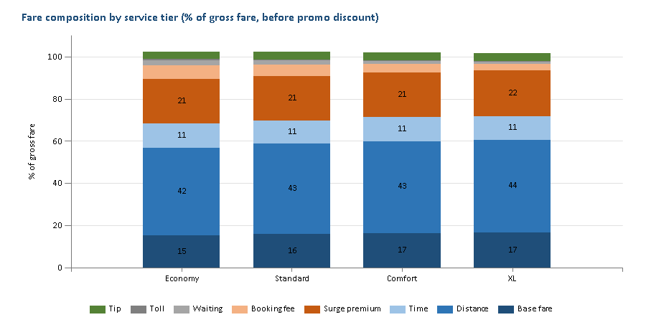
Figure 7.6 - Fare composition by service tier (Q07)
Distance is the largest component (42-44% of gross fare), followed by surge premium at about 21% in every tier - one rand in five that riders pay is surge. The fixed booking fee is regressive: it is 6.5% of an Economy fare but only 3.2% of an XL fare. Promotional discounts reduce gross fare by about 2%.

RQ8 - Spend efficiency by distance
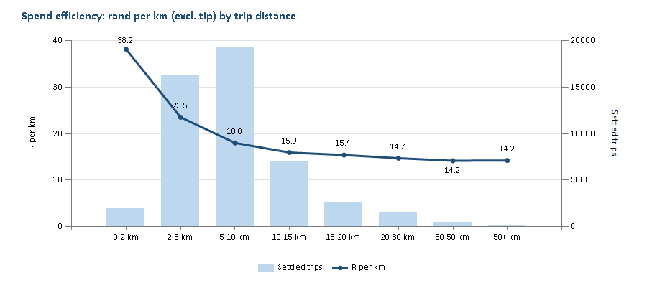
Figure 7.7 - Rand per km and trip volume by distance band (Q08)
Short trips are expensive per kilometre: R38.15/km under 2 km, falling to R18.00/km at 5-10 km. Beyond 15 km each band saves riders less than R0.70/km, and the curve is flat from 30 km (R14.18 vs R14.24). R/km stops falling at about 15 km. Almost three-quarters of settled trips fall in the 2-10 km bands, where fixed charges still weigh heavily.

RQ9 - When riders spend
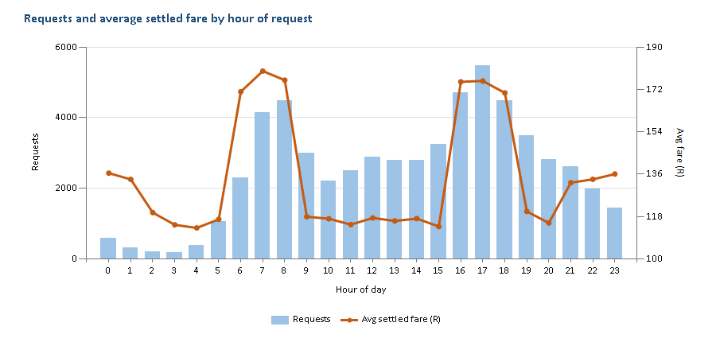
Figure 7.8 - Requests and average settled fare by hour (Q09)
Rank | Day | Hour | Settled trips | Avg fare | Revenue
1 | Wed | 17:00 | 663 | R177.16 | R117 459
2 | Fri | 17:00 | 676 | R170.00 | R114 922
3 | Sun | 17:00 | 624 | R182.79 | R114 062
4 | Mon | 17:00 | 641 | R176.09 | R112 873
5 | Sat | 17:00 | 624 | R179.23 | R111 837
6 | Thu | 17:00 | 604 | R173.27 | R104 653
7 | Tue | 17:00 | 608 | R170.75 | R103 819
8 | Sat | 16:00 | 557 | R180.70 | R100 651
9 | Fri | 08:00 | 544 | R180.40 | R98 135
10 | Tue | 07:00 | 504 | R190.03 | R95 774
Table 7.7 - Top ten day-and-hour revenue windows (Q09b, DENSE_RANK)
The two commuter peaks (06:00-08:59 and 16:00-18:59) carry 42.6% of requests and 51.5% of settled revenue. The average peak fare is R175 against R120 off-peak, almost entirely because surge averages 1.56-1.58x in those hours versus 1.05-1.23x otherwise. The 17:00 hour is the top revenue window on every day of the week.
Day type | Days | Requests | Requests / day | Avg settled fare | Cash share
Weekend | 102 | 16 674 | 163.5 | R148.05 | 27.49%
Public holiday | 12 | 1 945 | 162.1 | R141.95 | 27.10%
Weekday | 251 | 41 381 | 164.9 | R141.33 | 26.87%
Table 7.8 - Weekday, weekend and public holiday demand (Q09c, using the supplementary holiday table)
Public holidays and weekends generate the same daily demand as weekdays (162-165 requests per day). Weekend fares are R7 higher. Holidays do not need separate capacity or promotional planning.

RQ10 - Revenue concentration
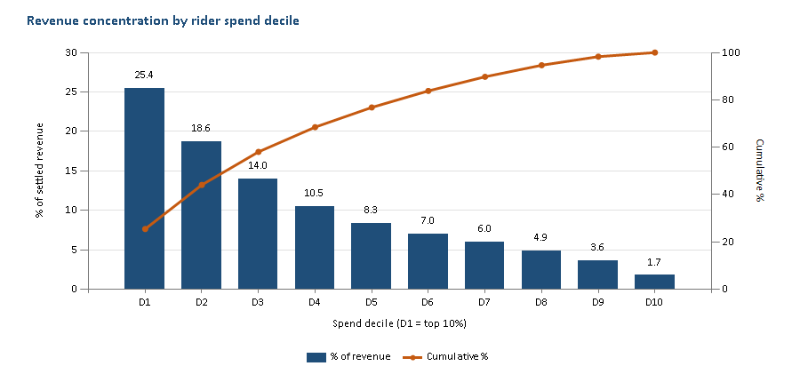
Figure 7.9 - Share of settled revenue by rider spend decile (Q10, NTILE)
Cohort | Riders | Avg trips | Avg fare | Airport trips | "Frequent" segment | Corporate | Gold / Platinum | Prefer cash
Top 10% | 315 | 36.1 | R157.00 | 22.43% | 98.10% | 1.90% | 19.37% | 30.48%
Other 90% | 2 829 | 13.3 | R139.05 | 16.25% | 16.40% | 7.49% | 19.16% | 27.54%
Table 7.9 - Profile of the top spend decile (Q10b)
The top 10% of riders generate 25.44% of settled revenue and the top 30% generate 58.03%. The top decile is defined by frequency (36.1 trips each, 98.1% in the Frequent segment) rather than loyalty tier, which barely differs from the rest (19% Gold or Platinum in both). Notably, the most valuable riders prefer cash slightly more often (30.5% vs 27.5%) and take more airport trips. The loyalty tiers do not currently recognise the platform's best customers.

RQ11 - Airport trips
Trip type | Requests | Avg km | Avg settled fare | Digital share | Tip rate | Payment failure | Completion
Non-airport | 49 327 | 6.88 | R127.86 | 72.85% | 33.72% | 2.32% | 81.85%
Airport | 10 673 | 11.95 | R214.67 | 73.37% | 33.58% | 2.21% | 81.28%
Table 7.10 - Airport vs non-airport trips (Q11)
Airport trips are 17.8% of requests but a distinct high-value basket: R214.67 on average, 1.68x a normal trip, driven by distance (11.95 km vs 6.88 km). Payment mix, tip rate and failure rate are the same as for other trips, so airport riders behave like everyone else once distance is removed.
Insight: spend is driven by distance and surge, not by instrument, province or loyalty tier. Revenue is concentrated in a frequent-rider decile that still leans on cash, and the commuter peaks are where most money changes hands.

Theme C - Tipping behaviour

RQ12 - Tips by payment method
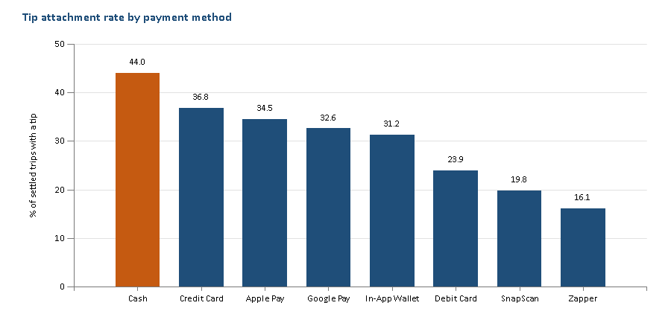
Figure 7.10 - Tip attachment rate by payment method (Q12)
Payment method | Settled trips | Tip attach rate | Avg tip when tipped | Avg tip per trip | Tips as % of driver payout
Cash | 13 433 | 43.99% | R15.29 | R6.72 | 5.99%
Credit Card | 11 616 | 36.82% | R15.33 | R5.65 | 5.02%
Apple Pay | 1 947 | 34.51% | R14.99 | R5.17 | 4.55%
Google Pay | 1 259 | 32.57% | R15.72 | R5.12 | 4.55%
In-App Wallet | 6 926 | 31.23% | R15.31 | R4.78 | 4.24%
Debit Card | 9 872 | 23.93% | R15.35 | R3.67 | 3.32%
SnapScan | 2 428 | 19.81% | R14.91 | R2.95 | 2.71%
Zapper | 1 568 | 16.07% | R17.32 | R2.78 | 2.57%
Table 7.11 - Tipping by payment method
The size of a tip is the same everywhere (R15-R17 when given). What changes is whether a tip is given at all: 43.99% of cash trips versus 16.07% for Zapper. Across all digital instruments the average tip is R4.58 per trip against R6.72 for cash - a gap of R2.14 per trip. Moving every cash trip in the dataset to the digital average would cost drivers about R28 792 a year in tips. Tips make up 6.0% of driver payout on cash trips and 2.6-3.3% on debit card, Zapper and SnapScan.

RQ13 - Does service quality earn tips?
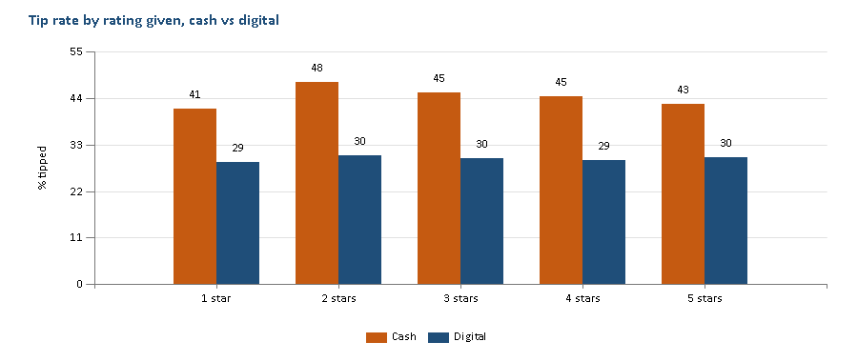
Figure 7.11 - Tip rate by rating given, cash vs digital (Q13, PIVOT)
No. Within each channel the tip rate barely moves between a one-star and a five-star review (cash 41-48%, digital 29-30%), while the cash-digital gap holds at every rating. Average tip value is in fact slightly lower for five-star reviews (R4.89) than for two-star reviews (R5.58). The 'Pricing & Payment' review category is more common in low ratings (18.5% at one star vs 15.4% at five stars). The data cannot show causation, but the pattern is consistent with tipping being driven by the payment moment - cash in hand - rather than by the ride.

RQ14 - Does surge suppress tipping?
Surge band | Settled trips | Tip rate | Index vs no surge | Avg tip | Avg fare
No surge | 23 632 | 33.70% | 1.000 | R3.94 | R110.00
1.01-1.25 | 4 812 | 33.33% | 0.989 | R4.51 | R125.38
1.26-1.50 | 7 744 | 34.26% | 1.017 | R5.48 | R149.03
1.51-2.00 | 10 006 | 33.68% | 0.999 | R6.79 | R188.32
>2.00 | 2 855 | 32.75% | 0.972 | R9.89 | R274.40
Table 7.12 - Tipping by surge band against a no-surge baseline subquery (Q14)
Not materially. The tip rate stays within 3% of the no-surge baseline in every band (index 0.972-1.017); the average tip rises with surge only because surged fares are larger. Surge has a much larger effect on cancellations (RQ17, Figure 7.13).
Insight: payment channel is the dominant driver of tipping; rating and surge are not. Any cash-to-digital migration cuts driver income unless the digital checkout makes tipping as natural as handing over change.

Theme D - Payment failure and revenue leakage

RQ15 - Failure rate and value lost
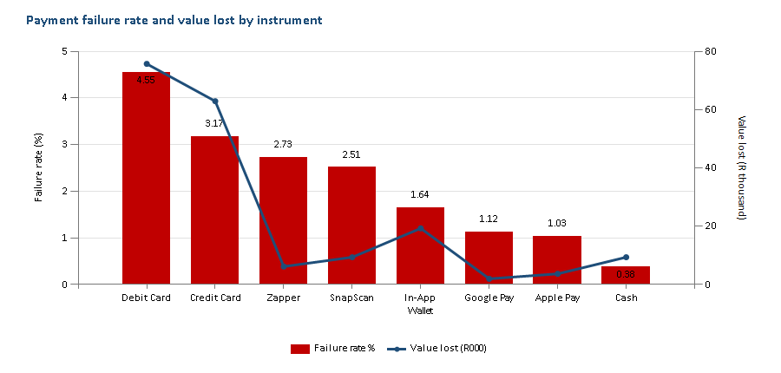
Figure 7.12 - Payment failure rate and value lost by instrument (Q15)
Payment method | Requests | Failed | Failure rate | Fare value lost | Est. commission lost | % of total loss
Debit Card | 12 339 | 562 | 4.55% | R75 710 | R17 291 | 40.17%
Credit Card | 14 334 | 454 | 3.17% | R62 868 | R14 461 | 33.35%
Zapper | 1 904 | 52 | 2.73% | R6 185 | R1 446 | 3.28%
SnapScan | 2 953 | 74 | 2.51% | R9 428 | R2 078 | 5.00%
In-App Wallet | 8 378 | 137 | 1.64% | R19 302 | R4 359 | 10.24%
Google Pay | 1 521 | 17 | 1.12% | R1 957 | R421 | 1.04%
Apple Pay | 2 339 | 24 | 1.03% | R3 675 | R833 | 1.95%
Cash | 16 232 | 62 | 0.38% | R9 357 | R2 092 | 4.96%
Total | 60 000 | 1 382 | 2.30% | R188 482 | R42 981 | 100.00%
Table 7.13 - Payment failures by instrument. Commission is estimated from each driver's contracted rate because failed fares carry R0 commission in the source.
1 382 requests (2.30%) failed at payment, losing R188 482 in fares and an estimated R42 981 in platform commission over the year. Debit card is the worst instrument at 4.55% - twelve times the cash rate and almost three times the in-app wallet. Tokenised mobile wallets (Apple Pay, Google Pay) fail on about 1% of requests. If the debit-card riders had failed at the wallet rate, about 360 failures and R48 497 of lost fares would have been avoided. All failures carry the reason 'Card Declined', so the data cannot split insufficient funds from technical declines.

RQ16 - What riders do after a failure
After event | No trip within 30 days | Returned - same instrument | Returned - switched to cash | Returned - other digital
Payment Failed | 17.82% | 52.21% | 9.38% | 20.58%
Completed | 18.21% | 52.23% | 7.27% | 22.28%
Table 7.14 - Rider behaviour in the 30 days after a payment failure vs after a completed trip (Q16, LEAD)
A failed payment does not drive riders away: 17.82% take no trip in the next 30 days, the same as after a successful trip (18.21%). It does change how they pay: 9.38% come back on cash, against 7.27% after a completed trip - 29% more likely to fall back to cash. Each card decline quietly undoes digital adoption.

RQ17 - Surge-driven abandonment
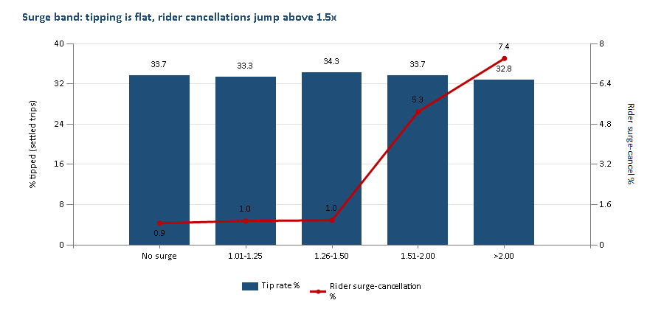
Figure 7.13 - Tip rate and rider surge-cancellation rate by surge band (Q14, Q17b)
Rank | Zone | City | Type | Avg surge | Surge cancels | Cancel rate | Supply index | Est. revenue lost
1 | OR Tambo Precinct | Johannesburg | Airport | 1.61 | 116 | 5.05% | 0.96 | R30 827
2 | CTIA Precinct | Cape Town | Airport | 1.48 | 83 | 4.76% | 1.24 | R17 234
3 | King Shaka Precinct | Durban | Airport | 1.55 | 72 | 4.21% | 1.05 | R14 893
4 | Durban CBD | Durban | Business District | 1.61 | 77 | 4.45% | 0.63 | R12 519
5 | Umhlanga | Durban | Nightlife | 1.48 | 77 | 4.28% | 0.95 | R11 262
6 | Sea Point | Cape Town | Nightlife | 1.52 | 62 | 3.68% | 1.07 | R9 447
7 | Centurion | Pretoria | Business District | 1.52 | 63 | 4.08% | 1.02 | R9 414
8 | Pretoria CBD | Pretoria | Business District | 1.47 | 54 | 3.61% | 0.98 | R8 135
9 | Rosebank | Johannesburg | Residential | 1.29 | 47 | 2.11% | 0.79 | R7 427
10 | Fourways | Johannesburg | Residential | 1.30 | 43 | 1.90% | 0.48 | R7 048
Table 7.15 - Ten zones with the highest estimated revenue lost to rider surge-friction cancellations (Q17, RANK)
Riders tolerate surge up to 1.5x: rider cancellations for surge friction stay below 1% of requests. Above 1.5x they jump to 5.29%, and to 7.41% above 2.0x, while completion falls from 82.8% to 79.0%. The three airport precincts (OR Tambo, Cape Town International and King Shaka) top the loss ranking and account for R62 953 of the R128 204 estimated in the top ten zones. Durban CBD is the clearest supply problem: a supply index of 0.63 alongside an average surge of 1.61x.
Insight: revenue leaks through two holes - card declines (R188k in fares, concentrated in debit cards) and surge above 1.5x (concentrated in airport precincts). Failures also push riders back to cash, so fixing them supports the migration goal directly.

Theme E - Promotions and rider retention

RQ18 - Do promotions bring riders back sooner?
Cohort | Settled trips | % of trips | Promo cost | Avg discount | Avg fare | Avg days to next trip | Repeat within 30 days
Discounted | 5 405 | 11.02% | R143 127 | R26.48 | R117.34 | 20.44 | 81.13%
Full price | 43 644 | 88.98% | R0 | - | R146.42 | 20.42 | 80.94%
Table 7.16 - Discounted vs full-price trips (Q18, LEAD)
11.02% of settled trips carried a discount, averaging R26.48 and costing R143 127 in total. Discounted riders returned after 20.4 days on average and 81.1% rode again within 30 days - indistinguishable from full-price riders (20.4 days, 80.9%). Discounts also land on cheaper trips (R117 vs R146). As currently allocated, the promotion budget does not change behaviour.

RQ19 - RFM segmentation
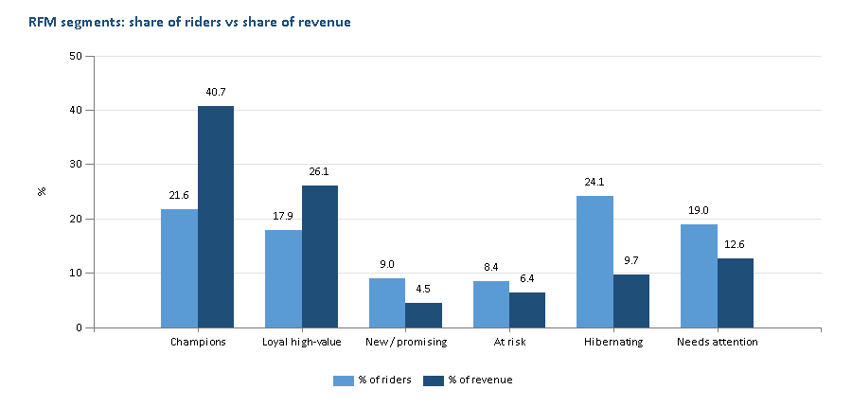
Figure 7.14 - Share of riders vs share of revenue by RFM segment (Q19)
RFM segment | Riders | Avg recency (days) | Avg trips | Avg spend | % of revenue | Cash share | Payment failure
Champions | 680 | 6.3 | 29.2 | R4 202 | 40.67% | 26.80% | 2.23%
Loyal high-value | 562 | 27.6 | 22.7 | R3 261 | 26.09% | 25.28% | 2.30%
New / promising | 283 | 7.1 | 7.8 | R1 122 | 4.52% | 29.53% | 3.06%
At risk | 264 | 51.9 | 12.0 | R1 690 | 6.35% | 28.81% | 1.86%
Hibernating | 759 | 82.3 | 6.3 | R900 | 9.73% | 26.87% | 2.64%
Needs attention | 596 | 14.3 | 10.5 | R1 490 | 12.64% | 29.80% | 2.20%
Table 7.17 - RFM segments scored with NTILE(5) on recency, frequency and monetary value (Q19)
680 Champions (21.6% of transacting riders) generate 40.67% of revenue; Champions and Loyal high-value riders together generate 66.8%. At the other end, 759 Hibernating riders (last trip 82 days before year-end) produce under 10%. 264 At-risk riders were frequent but have not ridden for 52 days on average - the segment where a retention offer has the most to win back. New and promising riders have the highest payment failure rate (3.06%), so a decline early in a rider's life is a risk to an emerging relationship.
Insight: promotions are spent without effect, while a clear RFM structure exists to target them. Redirecting the same budget to At-risk riders and to wallet adoption gives it a job to do and a result to measure.

Recommendations
Each recommendation follows from a finding above, names an owner and states how success would be measured. Rand values are estimates based on the twelve-month dataset.
# | Action | Evidence | Owner | Measure of success
1 | Wallet-first migration campaign in Potchefstroom and Vanderbijlpark, aimed at 18-24 riders: promote the in-app wallet (top-up at retail and EFT) and Apple / Google Pay, not debit cards. | RQ2, RQ3: highest cash share (38.8%, 33.1%); 18-24 cash preference 37.4%; wallet failure 1.0-1.6% vs debit 4.55% | Growth / Payments | Cash share in target cities down 5 points in six months; no rise in failure rate
2 | Debit-card decline recovery: on a decline, offer the wallet or a saved alternative in the same screen and retry once before cancelling. | RQ15, RQ16: R188 482 lost; debit card 40% of loss; 29% higher fallback to cash after a failure | Payments | Payment-failure loss down 30% (about R56 545/yr); post-failure cash fallback back to 7%
3 | In-app tip prompt at trip completion for every digital payment, with one-tap R10 / R15 / R20 options. | RQ12-RQ14: tipping depends on channel, not rating or surge; digital trips earn R2.14 less per trip | Product / Driver experience | Digital tip attachment from 30% towards the 44% cash rate
4 | Cap or smooth surge at 1.5x in the three airport precincts and Durban CBD, and add supply incentives in Durban CBD. | RQ17: surge cancellations jump from <1% to 5-7% above 1.5x; airports carry R62 953 of top-ten losses | Pricing / Supply ops | Rider surge-cancellation rate in these zones below 2%; completion rate above 82%
5 | Reallocate the promotion budget from untargeted discounts to (a) At-risk riders and (b) a one-off wallet top-up bonus for cash riders. Run it as a controlled test. | RQ18, RQ19: R143 127 spent with no effect on return interval; 264 At-risk riders identified | Marketing / CRM | Discounted cohort returns at least 3 days sooner than control; At-risk reactivation rate
6 | Recognise frequency in the loyalty programme. Upgrade the top-decile Frequent riders, and use the upgrade to introduce the wallet. | RQ10: top 10% = 25.4% of revenue yet the same tier mix as everyone else; 30.5% prefer cash | Loyalty / CRM | Top-decile retention; digital share of top-decile trips
Table 8.1 - Actionable recommendations
Recommendations 1 and 3 must ship together: moving riders off cash without a tip prompt transfers income from drivers to nobody. Recommendation 2 protects every other action, because each decline sends a rider back to cash.

Limitations and Conclusion

Limitations
- Observational data. The analysis shows associations, not causes. The tipping and promotion findings in particular should be confirmed with controlled tests before large budgets move.
- Coarse failure reason. Every payment failure is recorded as 'Card Declined'; insufficient funds, expired cards and network timeouts cannot be separated.
- Preference at extract time. preferred_payment_method reflects the rider's setting at the end of the period, not at each trip (RQ4).
- Revenue-loss estimates. Cancelled requests carry no fare, so lost value in RQ17 is estimated from each zone's average settled fare, and lost commission in RQ15 from each driver's contracted rate.
- Review self-selection. Reviews cover 41.8% of completed trips, so RQ13 describes riders who chose to leave a review.
- Dataset character. Several distributions (for example, tip rate across ratings) are very even, which may reflect how the dataset was generated. Findings are stated for this dataset and would need validation on production data.

Conclusion
The group implemented the Phase 1 design as a normalised, fully constrained SQL Server database, loaded all 135 949 records in a single reconciled transaction, and answered all nineteen research questions with 28 queries using multi-table joins, outer joins, grouping sets, PIVOT, CTEs and window functions. Indexes chosen from the workload cut logical reads by 91-99.5% on the tested queries, and a transactional stored procedure with a guarding trigger shows the database keeping its rules under concurrent updates.
The analysis answers the Phase 1 question of which riders can be moved from cash to digital without losing the trip. Cash is a stable safety net used most by young riders in the smaller metros; it persists because the most accessible digital instrument, the debit card, fails too often. The platform's best lever is therefore a reliable wallet, introduced where cash dependency is highest, paired with an in-app tip prompt and funded by redirecting a promotion budget that currently changes nothing.

Appendix A - Data Dictionary
Generated from the SQL Server catalogue (sys.columns, sys.foreign_key_columns, sys.indexes, sys.check_constraints) after the load. Key: PK primary key, FK foreign key (target shown), UQ unique, CK column has a CHECK constraint, CALC persisted computed column.
ride.province (5 rows)
Column | Data type | Null | Keys / constraints | Default
province_code | char(3) | NOT NULL | PK
province_name | varchar(20) | NOT NULL | UQ
ride.city (7 rows)
Column | Data type | Null | Keys / constraints | Default
city_id | tinyint | NOT NULL | PK, IDENTITY
city_name | varchar(20) | NOT NULL | UQ
province_code | char(3) | NOT NULL | FK > province.province_code
ride.zone (37 rows)
Column | Data type | Null | Keys / constraints | Default
zone_id | char(5) | NOT NULL | PK
zone_name | varchar(30) | NOT NULL | UQ
city_id | tinyint | NOT NULL | FK > city.city_id, UQ
zone_type | varchar(20) | NOT NULL | CK
base_fare_zar | decimal(6,2) | NOT NULL | CK
per_km_rate_zar | decimal(6,2) | NOT NULL | CK
per_minute_rate_zar | decimal(6,2) | NOT NULL | CK
minimum_fare_zar | decimal(6,2) | NOT NULL | CK
booking_fee_zar | decimal(6,2) | NOT NULL | CK
avg_surge_multiplier | decimal(4,2) | NOT NULL
max_surge_multiplier | decimal(4,2) | NOT NULL
peak_window | varchar(11) | NOT NULL | CK
avg_driver_supply_index | decimal(4,2) | NOT NULL | CK
toll_route_flag | bit | NOT NULL
ride.payment_method (8 rows)
Column | Data type | Null | Keys / constraints | Default
payment_method_id | tinyint | NOT NULL | PK
method_name | varchar(15) | NOT NULL | UQ
channel_group | varchar(13) | NOT NULL | CK
is_digital | bit | NOT NULL
ride.ride_category (8 rows)
Column | Data type | Null | Keys / constraints | Default
ride_category_id | tinyint | NOT NULL | PK
category_name | varchar(15) | NOT NULL | UQ
platform | varchar(5) | NOT NULL | CK
service_tier | varchar(10) | NOT NULL | CK
base_fare_zar | decimal(6,2) | NOT NULL | CK
ride.cancellation_reason (10 rows)
Column | Data type | Null | Keys / constraints | Default
cancellation_reason_id | tinyint | NOT NULL | PK
reason_text | varchar(25) | NOT NULL | UQ
reason_group | varchar(11) | NOT NULL | CK
ride.rider (3 200 rows)
Column | Data type | Null | Keys / constraints | Default
rider_id | char(7) | NOT NULL | PK, CK
first_name | varchar(40) | NOT NULL
last_name | varchar(40) | NOT NULL
age_band | varchar(6) | NOT NULL | CK
gender | varchar(20) | NOT NULL | CK
home_city_id | tinyint | NOT NULL | FK > city.city_id
signup_date | date | NOT NULL
preferred_payment_method_id | tinyint | NOT NULL | FK > payment_method.payment_method_id
loyalty_tier | varchar(10) | NOT NULL | CK
rider_segment | varchar(12) | NOT NULL | CK
corporate_account_flag | bit | NOT NULL
avg_rider_rating | decimal(3,2) | NOT NULL | CK
account_status | varchar(10) | NOT NULL | CK
ride.vehicle (900 rows)
Column | Data type | Null | Keys / constraints | Default
vehicle_id | char(6) | NOT NULL | PK
make | varchar(20) | NOT NULL
model | varchar(30) | NOT NULL
model_year | smallint | NOT NULL | CK
vehicle_age_years | tinyint | NOT NULL
vehicle_category | varchar(10) | NOT NULL | CK
seats | tinyint | NOT NULL | CK
fuel_type | varchar(10) | NOT NULL | CK
colour | varchar(15) | NOT NULL
licence_plate | varchar(12) | NOT NULL | UQ
roadworthy_expiry | date | NOT NULL
inspection_status | varchar(8) | NOT NULL | CK
ride.driver (900 rows)
Column | Data type | Null | Keys / constraints | Default
driver_id | char(6) | NOT NULL | PK
vehicle_id | char(6) | NOT NULL | FK > vehicle.vehicle_id, UQ
first_name | varchar(40) | NOT NULL
last_name | varchar(40) | NOT NULL
platform | varchar(5) | NOT NULL | CK
operating_city_id | tinyint | NOT NULL | FK > city.city_id
onboarding_date | date | NOT NULL
driver_rating | decimal(3,2) | NOT NULL | CK
total_trips_lifetime | int | NOT NULL | CK
acceptance_rate_pct | decimal(5,2) | NOT NULL | CK
cancellation_rate_pct | decimal(5,2) | NOT NULL | CK
commission_rate_pct | decimal(4,1) | NOT NULL | CK
driver_status | varchar(12) | NOT NULL | CK
background_check_status | varchar(8) | NOT NULL | CK
ride.trip (60 000 rows)
Column | Data type | Null | Keys / constraints | Default
trip_id | char(8) | NOT NULL | PK, CK
rider_id | char(7) | NOT NULL | FK > rider.rider_id
driver_id | char(6) | NOT NULL | FK > driver.driver_id
ride_category_id | tinyint | NOT NULL | FK > ride_category.ride_category_id
request_timestamp | datetime2(0) | NOT NULL
pickup_timestamp | datetime2(0) | NULL
dropoff_timestamp | datetime2(0) | NULL
pickup_zone_id | char(5) | NOT NULL | FK > zone.zone_id
dropoff_zone_id | char(5) | NOT NULL | FK > zone.zone_id
trip_distance_km | decimal(6,2) | NULL | CK
trip_duration_min | decimal(6,1) | NULL | CK
wait_time_min | decimal(4,1) | NOT NULL | CK
surge_multiplier | decimal(4,2) | NOT NULL | CK
trip_status | varchar(20) | NOT NULL | CK
cancellation_reason_id | tinyint | NULL | FK > cancellation_reason.cancellation_reason_id
payment_method_id | tinyint | NOT NULL | FK > payment_method.payment_method_id
is_airport_trip | bit | NOT NULL
hour_of_day | tinyint | - | CALC
day_of_week_no | tinyint | - | CALC
is_weekend | bit | - | CALC
request_date | date | - | CALC
ride.trip_fare (50 431 rows)
Column | Data type | Null | Keys / constraints | Default
fare_id | char(8) | NOT NULL | PK
trip_id | char(8) | NOT NULL | FK > trip.trip_id, UQ
base_fare_zar | decimal(8,2) | NOT NULL | CK
distance_charge_zar | decimal(8,2) | NOT NULL | CK
time_charge_zar | decimal(8,2) | NOT NULL | CK
surge_premium_zar | decimal(8,2) | NOT NULL | CK
booking_fee_zar | decimal(6,2) | NOT NULL | CK
toll_fee_zar | decimal(6,2) | NOT NULL | CK | 0
waiting_charge_zar | decimal(6,2) | NOT NULL | CK | 0
promo_discount_zar | decimal(6,2) | NOT NULL | CK | 0
tip_amount_zar | decimal(6,2) | NOT NULL | CK | 0
gross_fare_zar | decimal(9,2) | NOT NULL | CK
platform_commission_zar | decimal(8,2) | NOT NULL | CK
driver_net_payout_zar | decimal(9,2) | NOT NULL | CK
payment_status | varchar(8) | NOT NULL | CK
currency | char(3) | NOT NULL | CK | 'ZAR'
settlement_date | date | NULL
ride.trip_review (20 481 rows)
Column | Data type | Null | Keys / constraints | Default
review_id | char(9) | NOT NULL | PK
trip_id | char(8) | NOT NULL | FK > trip.trip_id, UQ
rating_given | tinyint | NOT NULL | CK
review_timestamp | datetime2(0) | NOT NULL
review_comment | varchar(200) | NULL
review_category | varchar(20) | NOT NULL | CK
sentiment_label | varchar(8) | NOT NULL | CK
escalated_flag | bit | NOT NULL
ride.public_holiday (12 rows)
Column | Data type | Null | Keys / constraints | Default
holiday_date | date | NOT NULL | PK
holiday_name | varchar(40) | NOT NULL

